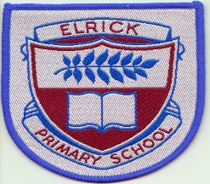
Starting @ Elrick School

What Will My Child Need to Start at Elrick School?

Many pupils transition straight from Nursery to Elrick Primary 1, but often due to family moves or a change in circumstances children join us throughout the year and at different stages of the school.
Pupils who join mid-way through a term will usually start school on a Monday and will be offered a welcome visit and tour in advance.
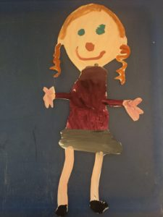
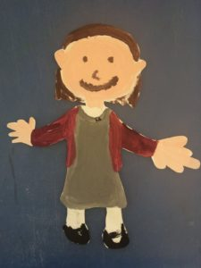
We encourage children to arrive wearing school uniform if possible. The link for the website is below and orders can be placed at any time.
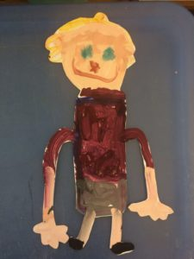
http://elrickps.imagescotland.com
If you are in receipt of certain benefits, you may be entitled to a grant towards school uniform – you can see and apply here –

Apply for a school clothing grant.

Waterproofs
At Elrick we encourage the outdoor environment to be utilised for learning opportunities as well as for social time. Living in Aberdeen, we need to do this in all weathers!! Children should have a waterproof coat that is warm enough for winter conditions. Where possible, we would ask that jackets are colourful or have reflective surfaces as in winter it can be dark when school finishes. Younger children who spend time in the messy garden will benefit from having waterproof trousers and wellies in school.

Food and Drink
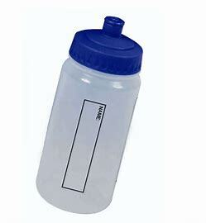
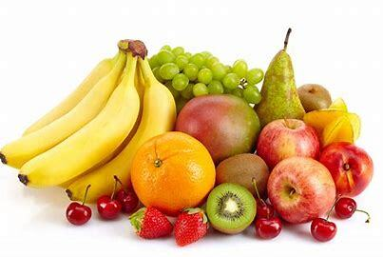
Children will also need a snack for their morning break. We encourage snacks to be healthy and request that grapes are halved. We have a No Nut policy.

We encourage our children to drink plenty of water throughout the day so each child should attend every day with a bottle of clean fresh water.

School Dinners
School dinners at Elrick are of excellent quality and are very popular. Food is made in the school kitchen by our Chef and her team.

Every day has a vegetarian option. If your child has any food requirements due to religious practices or allergies, please let us know and our catering team will work around that.
Throughout Scotland school dinners are free for children in Primary 1 to Primary 5.
If you are in receipt of certain benefits you may be entitled to free school meals – you can find out here and apply – Apply for free school meals
School dinner costs £2.50 per day. Information on how to pay for school lunches can be found in this example letter: Lunch Payment Information
Children do not have to have school lunches – they are welcome to bring a packed lunch from home and eat that with their friends. Again we request that grapes are halved and we operate a No Nut policy.

Information From Home
When your child starts at Elrick you will be given a rather daunting form to complete – please do not worry about this, but please do complete and return it to us quickly. This is the form where you can tell us who your emergency contact should be if your child needs collected from school, and you are unavailable. It also contains some pages regarding certain permissions that we need to request – permissions for trips out of school, permissions to take photographs of your child and use these in various ways.
Car Parking
The car park at school is for staff and visitors only and shouldn’t be used for dropping off children or picking them up (unless you have a blue badge).
We have storage for bikes and scooters and encourage families to leave the car at home for school drop offs and pickups if possible. Perhaps you could try to ‘Park and Stride’??

