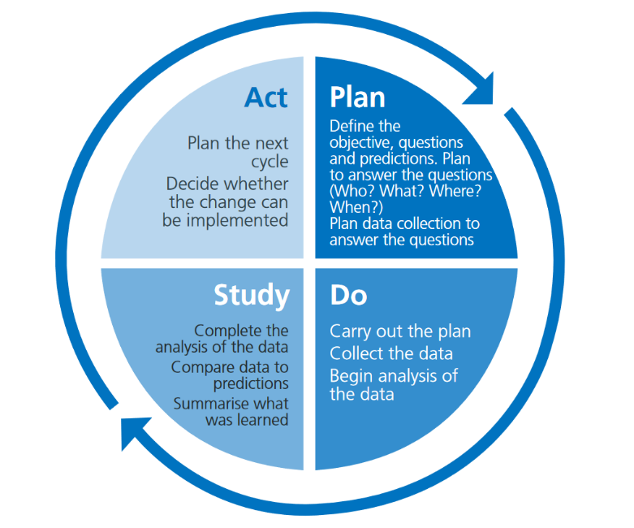
Setting Name: Elrick Nursery

Manager: Nicola McKinlay
PT: Hazel Fraser
Other Contributors: Staff Team

2021-2022 | 2022-2023
Key Strengths from Self Evaluation RAG | RAG Drivers and Priorities for Improvement
- Child Protection and Safeguarding – All staff are trained in Child Protection. Chronologies are in place. Staff are aware of the Child Protection procedure.  - Responsive Care and personalised support – Personal Care Plans are detailed and reflect GIRFEC. Support plans, risk assessments and IEPs are in place where needed. Multi-agency working is in place. | 1 | Learning, Teaching and Assessment  - Effective use of Assessments  - Planning, Tracking and Monitoring  - Progress in communication, early language, mathematics, health and wellbeing  Transitions  - Continuity and Progression in Learning
 | 2 | Leadership and Management  - Self-evaluation for self-improvement, reflection, and evaluation  - Leadership of learning, training, and development  - Management and implementation of Risk Assessments  Partnerships  - Engaging parents in the life of the setting

Action Plan 1:
RAG Driver |  | RAG Priority |  | Links to Key Documents
Learning, Teaching & Assessment  Transitions |  | - Effective use of Assessments  - Planning, Tracking and Monitoring  - Progress in communication, early language, mathematics, health and wellbeing  - Continuity and Progression in Learning |  | (H&SCS 1.27 and 1.6) (RTA 3.1, 6.2, 7.3 and 6.4)  (HGIOELC 2.3 and 3.2)  (FFC 2.2 and 4.2)  (QF 2.1, 3.2, 4.1, 5.2, 1.3 and 3.1)  (H&SCS 3.19)  (HGIOELC 2.6)  (FFC 6)  (RTA 4.4)  (QF 1.3, 2.1, 3.2)
Why are we doing this? |  |  |  | Intended Outcomes (What is going to change for children & families?)
RAG self-evaluation document and staff reflections evidenced that as a team we could improve our use of assessments, moderation and how to use these to plan for next steps in individual development using planning. This particularly applies to numeracy, literacy and health and wellbeing. |  |  |  | - Assessments will be an integral part of the learning and teaching in setting. These are used to effectively plan high quality learning experiences for all children. High quality observations will take place naturally every day. Parents and carers receive regularly and up to date information including learning profiles on their children’s learning and achievement. Both children and parents make valuable contributions to these profiles.  - In our setting information for every child will show that almost all children are making very good progress in literacy, numeracy and health and wellbeing as appropriate to their developmental stage. We will ensure high quality learning experiences are used to promote and enhance children’s development, successes, achievements, and progress. We will have high aspirations for achievement for children, staff and our families and we share this with them.  - Information about children’s learning and achievements particularly in key areas of early literacy, numeracy and health and wellbeing, will be used effectively to ensure continuity in learning across the curriculum for all children
Process |  |  |  | Measures
1 | What we are going to do? | Who | Timescale | How do we know if we have achieved this? | Date Completed
 | Include parents in making contributions to their child’s learning. Promote the use of learning leaves and working together with parents to develop their child’s interests and next steps.  Staff to incorporate next steps into planning and embed this into practice. Individual next steps to be displayed on clipboards in the playroom for the team to work on and develop when supporting the children on the floor.  Use the Aberdeenshire frameworks and baselines to support observations across Literacy, Numeracy and Health and wellbeing. | EYSP  EYLP  EYPs  Parents  Children  EYSP  EYLP  EYPs  EYSP  EYLP  EYPs | Ongoing  Term 2  ASAP/On going

Action Plan 2:
RAG Driver |  | RAG Priority |  | Links to Key Documents
Leadership and Management  Partnerships |  | - Self-evaluation for self-improvement, reflection, and evaluation  - Leadership of learning, training, and development  - Management and implementation of Risk Assessments  - Engaging parents in the life of the setting |  | (H&SCS 3.14, 4.19)  (FFC 1.1, 1.4, 4.1, 4.2)  (HGIOELC 1.1) (RTA 7.3)  (QF 3.1)  (H&SCS 4.18)  (RTA 7.2)  (FFC 5.1 and 5.2)  (HGIOELC 2.7)  (QF 1.4)
Why are we doing this? |  |  |  | Intended Outcomes (What is going to change for children & families?)
RAG self-evaluation document and staff reflections evidenced that as a team we could improve our involvement of all stakeholders, in particular parents to evaluate and be included within the setting.  Staff will be proactive in seeking CPD and record learning.  Risk assessments will be reviewed regularly and updated in accordance with the QA calendar. |  |  |  | - Staff will be highly reflective, evaluative and involve all stakeholders in this process. This leads to continuous improvement and improves outcomes for children.  - All staff will engage in continuous professional development. Records are in place to evidence professional learning with clear links to improvement plans and personal targets. Outcomes for children are improved due to increase in staff knowledge and skills.  - All benefit risk assessments will be in place and up to date. Those will include individual risk assessments for those who require them. Current policy and guidance documents will be used throughout. The QA calendar supports the regular review of risk assessments, and these are shared with stakeholders for discussion. There is a clear understanding in setting of how these are implemented and subsequently these are having a significant positive impact in the setting.  - The views of parents will be sought and valued more often. They will be used to ensure that the setting reflects the needs of children and families. Parents will feel ownership of the setting.
Process |  |  |  | Measures
1 | What we are going to do? | Who | Timescale | How do we know if we have achieved this? | Date Completed
 | Staff to continuously audit and evaluate the environment (zones) and activities. Use the leuven scale to measure engagement.  Staff to seek CPD, improve professional development where they can. Evaluate this and put what they have learnt into practice, sharing findings with the team.  Risk assessments and individual risk assessments for those who require them to be in place and reviewed regularly, to be displayed on the QA calender.  As a team introduce more ways to seek parents’ views and ensure they feel part of the setting. Set up family nurture. | All staff  All staff  EYSP  EYLP  All staff | Ongoing  Ongoing  End of Year  ASAP

