ELRICK PRIMARY SCHOOL PARENT COUNCIL MINUTES
Monday 26 September 2022, 7.00 pm

Location: via Microsoft Teams

Attendees: Christina Daniel (Chair), Claire Watt (Treasurer), Leanne Lawson (Secretary), Amy Simpson (Social Media Officer), Kelly Anderson (Fundraising Coordinator), Shyama Shiaham (Grants Coordinator), Stephanie Bain (Vice Secretary), Fiona Thomson (Head Teacher), Jenny Anderson (Deputy Head), Jill Stockdale (Deputy Head), Cllr Iris Walker (Local Councillor), Bruce Bain (Parent), Monique Blair (Parent), Fiona Fitzgerald (Parent), Angela Wood (Parent), Karen Crane (Parent), Lauren Wade (Parent), Liyuan Yu (Parent), Lana van der Tooren (Parent), Jackeline Rodriguez (Parent), Nicola Johnston (Parent), Claire Taylor (Parent),
Apologies: Cllr Ron McKail (Local Councilor), Adele Megginson (Vice Chair), Lena Casey (Parent), Donna Snowie (Parent)
Presentation slides from the meeting are attached.
Review of the Minutes of the Last Meeting & Matters Arising
The minutes were agreed to be accurate.
Ref No | Date Raised | Action | Owner | Status
1119-11 | 12/11/2019 | Purchase candy floss machine – consider the size and where it might be stored | Claire Taylor | On hold
0920-03 | 22/09/2020 | Crisp Bag recycling - Jill engaging with Eco Committee | Jill Stockdale | On hold
1220-02 | 10/12/2020 | Numicon Resources – approx. £9200. Grant options to be investigated. | Shayma Shiaham | On open
0521-04 | 06/05/2021 | 40th Anniversary Afternoon Tea – look at venues and available dates | Kelly Anderson/Nicola Johnston | On Hold
02/22-02 | 07/02/2022 | Wish list and estimated budget required for Mindfulness project to be prepared (yoga matt, blankets, cozy dressing gown, books, app subscriptions, etc– consider funding (i.e. Amazon Wish List) or grant to cover | Erica Edwards | Open
02/22-04 | 07/02/2022 | Post AT meeting with CD and email from Annabel Turner from Cybersafe Scotland, FT to get back to her and let PC know what are the best options for school. | Fiona Thomson | Open
04/22-01 | 25/04/2022 | Fiona to take a photo of the new art Island and send it to Adele for issuing to WECC for bulletin. | Fiona Thomson | Open
06/22-01 | 13/06/2022 | Arrange Christmas Fayre sub group and set briefing meeting with Fiona T and Pupils Council | Christina Daniel | Open
06/22-02 | 13/06/2022 | Fiona has purchased the trophies using the Shell Kindness grant, invoice to be sent to the treasurer to reimburse. | Fiona Thomson | Open

CD welcomed everyone along to the meeting and provided a brief update on the following:
I would like to welcome and extend warm greetings to you all for joining us tonight.
Welcome to our newly elected office bearers, thank you for volunteering your time to join us on this journey.
We reviewed the actions outstanding from the previous meeting.
Head Teachers Report
Report is attached.
Financial Report
Having just covered the annual financial report, we did not go into this in great detail again.
We have a current balance of £12,886.27 laying aside ring fenced costs gives an available balance of £7,003.77

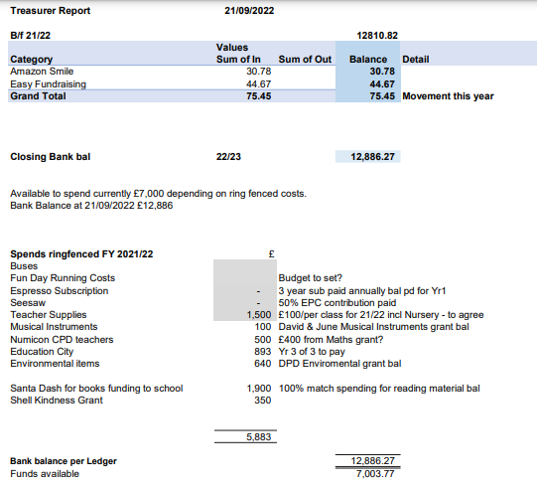
Grants
Nothing to report.

Fundraising
Halloween – Free entry pumpkin Carving Competition to go ahead. Cllr Iris Walker volunteered to judge.
Halloween – Dress down day. Mrs Thomson discussing with staff, could be too scary for some children. Similar feedback did come from some parents who were canvassed.
Friday after the October holidays is 4th Nov. If we wanted to dress down then, avoiding Halloween, could be for fireworks. Bright/ Sparkly/colorful. Also a PJ dress down is always a winner.

Halloween spooky stall – sell small items on the last day of term before October holiday.
Christmas Fayre 4th December – we are looking for volunteers to help organize. To be discussed in more detail at the pupil council meeting on Monday 03 October. All new parent council members are welcome.
2023 Calendar is underway as are the Christmas Cards Design templates.

Requests for Funding
Funding request for £172.51 for the 2- year subscription to the parent council email - approved
£100 per class teacher and including the ASL and Outdoor learning teachers - approved
Items raised by Class Reps
None.
AOCB
We are still missing class reps for P1M, P3N, P4S, P7A If you can volunteer please get in touch.
Mrs Thomson will ask the office to check if they emailed these classes.
There was a discussion that going forward it could be one rep per year group. This might be easier as classes often change and it results in trying to find who is in your class and if there is an existing group set up.

Dates of Next Meetings
7pm Monday 21st November via Teams – Link to be sent out in due course.

