ELRICK PRIMARY SCHOOL PARENT COUNCIL ANNUAL GENERAL MEETING (AGM) DRAFT MINUTES
26th September 2022, 7.00 pm
Location: Microsoft Teams
Attendees: Christina Daniel (Chair), Jackeline Rodriguez (Vice Chair), Nicola Johnston (Treasurer), Claire Watt (Vice Treasurer), Claire Taylor (Secretary), Fiona Thomson (Head Teacher), Jenny Anderson (Deputy Head), Cllr Iris Walker (Local Councillor), Bruce Bain (Parent), Monique Blair (Parent), Fiona Fitzgerald (Parent), Amy Simpson (Member), Angela Wood (Member), Karen Crane (Member), Kelly Anderson (Member), Lauren Wade (Member), Leanne Lawson (Member), Shyama Shiaham (Member), Stephanie Bain (Member), Liyuan Yu (Member),
Apologies: Cllr Ron McKail (Local Councillor), Adele Megginson (Grants Coordinator), Lana van der Tooren (Member), Lana Casey (Parent), Donna Snowie (Parent)
Presentation slides from the meeting are attached.
Review of the Minutes of the Last AGM on 08 September 2021 & Matters Arising
None
Chairperson’s Report for 2021/22
Please see the attached presentation from our chairperson, Christina.

Approval of Accounts for Year Ending 30 June 2022
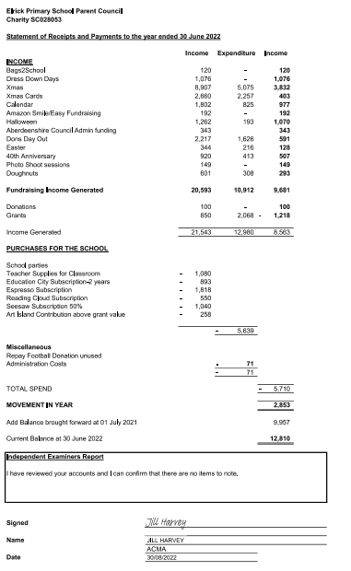

Appointment of Independent Examiner
Jill Harvey (ACMA) Institute of Chartered Accountants, has audited the accounts. This is required before they are submitted to the Office of the Scottish Charity Regulator (OSCR) as we are a registered charity.

Election of Office Bearers 2022-2023
The following Office Bearers were nominated for the academic year 2022-2023. There was only one nomination for each position, so no vote was required.
All present agreed to elect as below.
Post | Name(s) | Nominated/Seconded
Chair | Christina Daniel | Claire Taylor / Nicola Johnston
Vice Chair | Adele Megginson | Christina Daniel / Claire Watt
Treasurer | Claire Watt | Claire Taylor / Nicola Johnston
Vice Treasurer

Secretary | Leanne Lawson | Christina Daniel / Claire Watt
Vice Secretary | Stephanie Bain | Christina Daniel / Claire Watt
Grants Co-ordinator | Shayma Shiaham | Christina Daniel / Claire Watt
Fundraising Co-ordinator | Kelly Anderson | Christina Daniel / Claire Watt
Social Media Officer | Amy Simpson | Christina Daniel / Claire Watt
Ordinary Members | Shalaka Samant  Lana van der Tooren | Christina Daniel/Claire Taylor  Christina Daniel/Claire Taylor

AOCB
None

