ELRICK PRIMARY SCHOOL PARENT COUNCIL MINUTES
Monday 13 June 2022, 7.00 pm

Location: via Microsoft Teams

Attendees: Sophie Cartlidge (Pupil Council Chair), Rhys Allan (Pupil Council Secretary), Sophie Johnston (Pupil Council Vice Secretary), Christina Daniel (Chair), Jackeline Rodriguez (Vice Chair), Nicola Johnston (Treasurer), Claire Watt (Vice Treasurer), Claire Taylor (Secretary), Adele Megginson (Grants Coordinator), Fiona Thomson (Head Teacher), Jill Stockdale (Deputy Head), Cllr Iris Walker (Local Councillor), Cllr Fatima Joji (Local Councillor), Bruce Bain (Parent), Monique Blair (Parent), Elaine Cartlidge (Parent), Santana Kidd (Member),
Apologies: Fiona Fitzgerald (Parent), Cllr Ron McKail (Local Councillor), Melody Kuo (Member), Shalaka Salmant (Member), Lana van der Tooren (Member)
Presentation slides from the meeting are attached.
Review of the Minutes of the Last Meeting & Matters Arising
The minutes were agreed to be accurate.
Ref No | Date Raised | Action | Owner | Status
1119-11 | 12/11/2019 | Purchase candy floss machine – consider the size and where it might be stored | Claire Taylor | Open
0920-03 | 22/09/2020 | Crisp Bag recycling - Jill engaging with Eco Committee | Jill Stockdale | On hold
1220-02 | 10/12/2020 | Numicon Resources – approx £9200. Grant options to be investigated. | Adele Megginson | On hold
0521-04 | 06/05/2021 | 40th Anniversary Afternoon Tea – look at venues and available dates | Christina Daniel/Nicola Johnston | On Hold
02/22-02 | 07/02/2022 | Wish list and estimated budget required for Mindfullness project to be prepared (yoga matt, blankets, cosy dressing gown, books, app subscriptions, etc– consider funding (i.e. Amazon Wish List) or grant to cover | Erica Edwards | Open
02/22-04 | 07/02/2022 | Contact Cybersafe scotland to see what options are available to us. | Christina Daniel | Open
04/22-01 | 25/04/2022 | Fiona to take photo of new art Island and send to Adele for issuing to WECC for bulletin. | Fiona Thomson | Open
06/22-01 | 13/06/2022 | Arrange Fun Day sub group and set briefing meeting with Fiona T | Christina Daniel | Open
06/22-02 | 13/06/2022 | Fiona to arrange the purchse of trophies or awards using the Shell Kindness grant, these will be used to award the school’s charter of kind, respectful and safe | Fiona Thomson | Open

CD welcomed everyone along to the meeting and provide a brief update on the following:
I would like to welcome and extend warm greetings to you all for joining us tonight.
Can’t believe that this is the last meeting of this academic year and so looking forward for the summer holidays. This year has really flown by very quickly.
What a year this has been, with so many positive changes, feedback and achievements.
We will discuss options later on if you are interested to join us.

Head Teachers Report
Report is attached.
Financial Report
Nicola explained the we have a current balance of £13,414.52 laying aside ring fenced costs gives an available balance of £8,242.
Teachers expenses to be claimed by 17 June.
Community Kindness grant received from Shell, Mrs Thomson proposed using this for trophies/awards to mark the school’s ‘kind / respectful / safe’ charter. These could be distributed at assembly, to classes who demonstrate the school’s high standards. This was agreed and approved.
Previously ordered banners for outside school are due to be delivered.
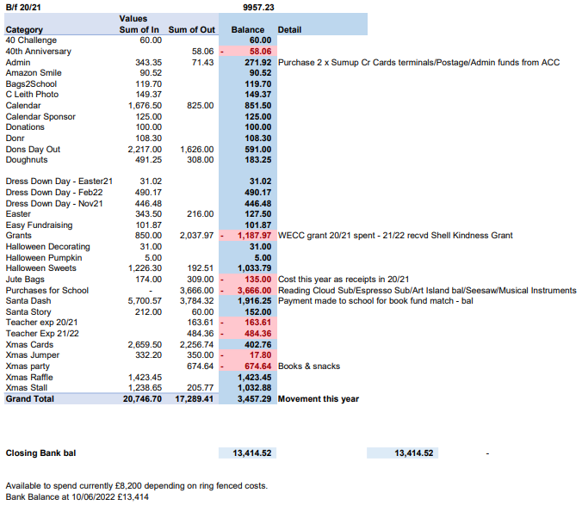

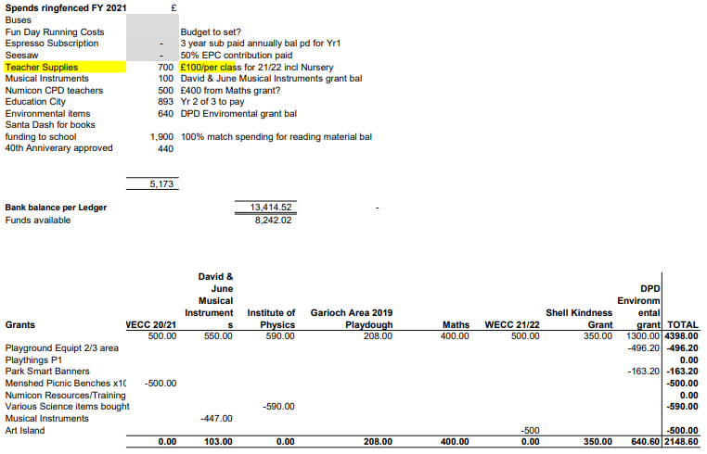
Grants
Adele Megginson was unable to attend the full meeting but did provide the following update.
Received £350 for Shell Community Kindness program. Could be used for anything, no restrictions.

Fundraising
Carol Leith photography sessions went ahead.
Elrick 40th Challenge went ahead and is just concluding.
Donut Day has seen a lot of preorders, small amount to be available to buy on the day.

Upcoming events;
Elrick 40th Extravaganza – community building rather that fundraising. To be held within school hours. Free entry disco, cake and much more.
Fun Day 17th September, we need to start planning now. Christina is to arrange a sub group and add the volunteers. We discussed setting up as much as possible inside on the Friday evening whilst the cleaners are in the building. School will be opened by Fiona on the Saturday morning, event will be run 12-3 with time before and afterwards for set up and set down. Sam in kitchen will ask kitchen staff if they would be willing to join us on the day and provide the BBQ.

Requests for Funding
- Clan Chiefs requested funding for hiring inflatables for end of term clan treat. They have raised circa £220 from sponge throwing but are short for the inflatables they are hoping to book. This goes against the constitution of fitting the majority of the pupils. We proposed and agreed an annual donation of £100 to clan chief treat.

Items raised by Class Reps
- Uniform swap shop – Gemma Waby-Christie has kindly agreed and has started to share photos of lost property on the parent council Facebook page to try and return items to their owner. We also discussed that after uniform items have not been claimed, we would like to do some sort of swap shop where parents can drop off uniform their children have grown out of and pick up uniform in the next size up. School were to consider further how and when this could be done. We did consider last day of term. Post meeting after having discussion with other school staff member decided to get in touch the Westhill community church to see if they would like to start the swap shop again so it will benefit the wider community.
- Will children still be able to wear gym kit on gym days. It is likely that they will be encouraged to take their gym kit with them and change at school, this is a life skill that they need practice at. It is recognized that some children will be show resistance to going back to uniform 5 days a week.
- Move the school forward, is it for children or for parents too? It is only for children.
- Since, there is no trip planned for P5, would there be any other opportunity for them to do something else? Each class teacher decided in a very short time after coming back from Easter holidays, when restrictions were eased. so, they might do something but if not then it will in new school year. Not every class in the school is going on a trip.

AOCB
None.

Dates of Next Meetings
AGM and General Meeting Monday 26 September 2022 at 7.00pm via MS Teams
Nominations for office bearers by 19 September. This will coincide with being after the schools ‘meeting the teacher evening’ which is an opportunity to introduce new parents to the parent council.

