ELRICK PRIMARY SCHOOL PARENT COUNCIL MINUTES
Monday 25 April 2022, 7.00 pm

Location: via Microsoft Teams

Attendees: Christina Daniel (Chair), Jackeline Rodriguez (Vice Chair), Nicola Johnston (Treasurer), Claire Watt (Vice Treasurer), Claire Taylor (Secretary), Adele Megginson (Grants Coordinator), Fiona Thomson (Head Teacher), Leah Robinson (Deputy Head), Jenny Anderson (Deputy Head), Cllr Ron McKail (Local Councillor), Cllr Iris Walker (Local Councillor), Cllr Alistair McKelvie (Local Councillor), Bruce Bain (Parent), Donna Snowie (Parent), Fiona Fitzgerald (Parent), Monique Blair (Parent),
Apologies: Santana Kidd(Member), Melody Kuo, Shalaka Salmant, Lana van der Tooren
Presentation slides from the meeting are attached.
Review of the Minutes of the Last Meeting & Matters Arising
The minutes were agreed to be accurate.
Ref No | Date Raised | Action | Owner | Status
1119-11 | 12/11/2019 | Purchase candy floss machine – consider the size and where it might be stored | Claire Taylor | Open
0920-03 | 22/09/2020 | Crisp Bag recycling - Jill engaging with Eco Committee | Jill Stockdale | On hold
1220-02 | 10/12/2020 | Numicon Resources – approx £9200. Grant options to be investigated. | Adele Megginson | On hold
1220-03 | 10/12/2020 | David and June Gordon Memorial Trust - the outdoor instuments have been purchased | Jenny Anderson | Closed
0221-01 | 04/02/2021 | Advice WECC on the status of the spend of their £500 donation towards picnic benches. Benches received. Photos and wording sent to WECC for inclusion in next bulletin. | Fiona Thomson | Closed
0521-04 | 06/05/2021 | 40th Anniversary Afternoon Tea – look at venues and available dates | Christina Daniel/Nicola Johnston | On Hold
0621-01 | 17/06/2021 | Elrick Extravanganza – Sub group meet and it was agreed a small scale event would proceed. | Fiona Fitzgerald | Closed
06/21-02 | 17/06/2021 | Playground Resurfacing – look for a volunteer to lead on fundraising  Waiting to hear back from council, might have to fundraise in future.  There will be school upgrades and those are likley to impact or include the playground surface, agreed to close this action for now. | Christina Daniel | Closed
10/21-01 | 11/10/2021 | 40th Anniversary Recipe books- to be completed as a homework excersise | Fiona Thomson/All Staff | Closed
02/22-01 | 07/02/2022 | External Notice board at front of school – Fiona T recieved a quote from MenShed and Funding was approved in this meeting. | Fiona Thomson | Closed
02/22-02 | 07/02/2022 | Wish list and estimated budget required for Mindfullness project to be prepared (yoga matt, blankets, cosy dressing gown, books, app subscriptions, etc– consider funding (i.e. Amazon Wish List) or grant to cover | Erica Edwards | Open
02/22-03 | 07/02/2022 | Wish list for Nursery received – consider funding or grant to cover | Nicola Scott | Closed
02/22-04 | 07/02/2022 | Contact Cybersafe scotland to see what options are available to us. | Christina Daniel | Open
04/22-01 | 25/04/2022 | Fiona to take photo of new art Island and send to Adele for issuing to WECC for bulletin. | Fiona Thomson | Open

CD welcomed everyone along to the meeting and provide a brief update on the following:
- Can’t believe that it is the last term of this academic year and so looking forward to be able to do more stuff in 2022 since restrictions are more eased.
- Positive feedback for PC received from parents for our events – Thank you!
- We will discuss options later on if you are interested to join us.
- We have a very exciting news to share today that our much awaited Fun Day is back this year after a long wait Hurray. We will discuss more about it later on in our fundraising section.

The following discussions took place in relation to the open actions;
Candy floss machine, there was a concern from school regarding storing in school, we need to check size and agree before we purchase. FT asked about borrowing form others, CT advised we used to hire / borrow the one used at gala day but it was unsafe and we did not want to use it again. We voted and agreed to purchase our own and hoped we could hire it out to the other schools.
Extravaganza, agreement was to keep it small scale, not to take away from the fun day. There is only 9 weeks until holidays and there is a lot on for PC and for the teaching team.
A question arose if the Pupil council be revoted in every year, FT suggested maybe not this year as they have not been long in office, FT to discuss with the pupil council at their next meeting and agree. There will be some gaps with P7’s leaving for academy.
Leah Robinson shared a presentation from the digital leaders, (they start from P5 onwards and can stay in the group, they meet each week. Their presentation shared their wish list;
Item | Link | Cost | Notes
Green Screen | Buy TTS Green Screening Kit | TTS (tts-group.co.uk) | £99.95 ex VAT£ 119.94 inc VAT
InO-Bots | Buy InO-Bot Scratch Programmable Bluetooth Floor Robot | TTS (tts-group.co.uk) | £109.99 ex VAT£ 131.99 inc VAT | 6 would be our ideal number
Docking Station | Buy InO-Bot Docking Station | TTS (tts-group.co.uk) | £36.99 ex VAT£ 44.39 inc VAT
Blue-Bots | Buy Blue-Bot® Bluetooth Programmable Robot Class Pack | TTS (tts-group.co.uk) | £449.94 ex VAT£ 539.93 inc VAT
Code Reader | TacTile Code Reader for Programming BeeBot® | TTS (tts-group.co.uk) | From £ 99.99
Chromebooks |  | Price TBC by LA
Headphones |  | Price TBC by LA
Mice |  | Price TBC by LA

Head Teachers Report
Report is attached.
Financial Report
Nicola explained the we have a current balance of £12,376 laying aside ring fenced costs gives an available balance of £7,028

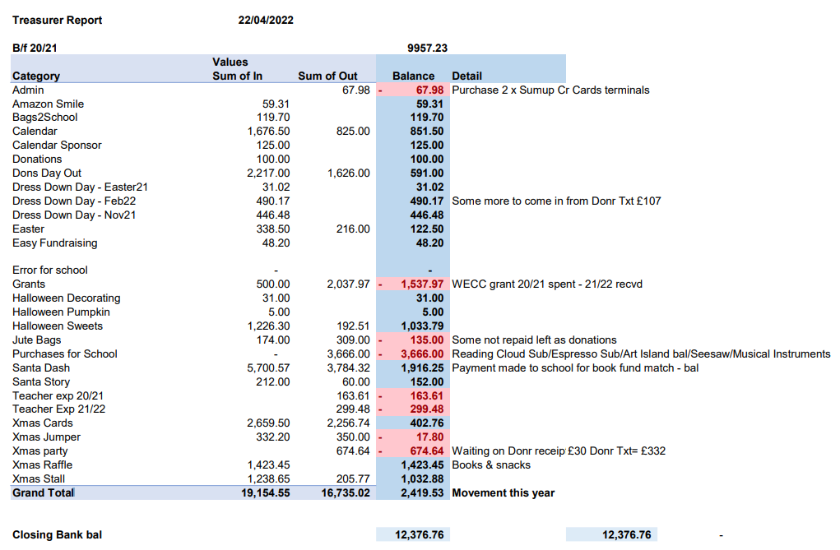
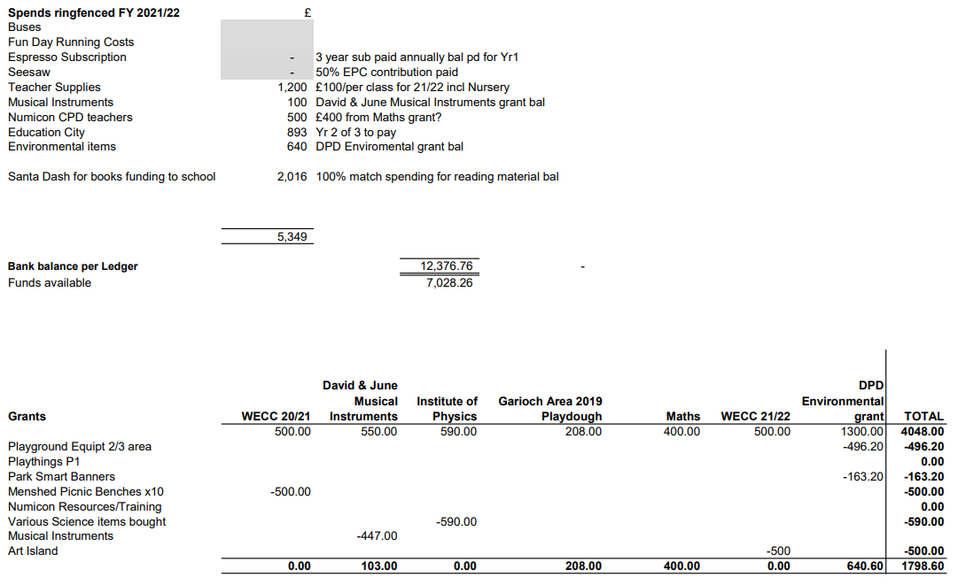

Fiona T advised they are going to spend remainder of the match funding on maths books once they sort out and evaluate what they have – all books out with classes being used makes this difficult.

Grants
Adele Megginson briefed group on some potential grants:
Investigating: Asda Challenge Funding, Aldi Sports Grant, Crowdfunder – Power to Change

Fiona T asked if the Aldi sports fund might be available to support the school netball and football teams. These are not generally supported by the parent council as they don’t fit with the constitution saying funding must benefit the majority of the school. Adele was to investigate this further.

Funding Focus: Received requests for woodwork equipment and outdoor learning materials. Mindfulness resources were also discussed. Request was made for additional information regarding technology requirements. Is there any more information regarding whiteboards, that would allow Adele to source a suitable grant.

Other Information/Updates: The Art Island from the WECC Grant was awaiting supplies, Fiona Thomson confirmed they had arrived and that she would get a photo for the WECC bulletin.

We have been provisionally accepted for Shell Community Kindness program, following being nominated by a parent and may receive £350.

Fundraising
Over that last while we have successfully ran the following;
Twos Day Dress Down on 22nd February.
Dons Day Out on 19th March. It was very well attended. Thank you to Bruce for helping us organise.
Easter Eggs Hunt Last week of March, positive feedback and thanks to Morrisons for donating 100 of the chocolate eggs. Every child received an egg.

Upcoming events;
Clan Chief dress down day - in colours of clans might include some sponge throwing at the clan chiefs, Friday 10 June, for them to raise funds specifically to pay for the end of term clan chief reward.
Elrick 40th Extravaganza – community building rather that fundraising, let us know if you want to help organize.
Donut day to be Wednesday before queens jubilee day, Wed 01 June.
Fun Day 17 September, start planning now. School to send a save the date email.
Carol Leith photography sessions.

Smarties Challenge.

Requests for Funding
- Mrs Neave - Outdoor storage box - £130 Approved
- Noticeboard x 1 to front of school - £220 Approved
- Easter eggs - £216 Approved
- Smarties - £105 Approved
- Book shelves for P3Y - £25 Approved
- Any other - £500 for Elrick Extravaganza Approved

The following were raised at the meeting;
- School asked if PC would consider part funding the renewal of the Bug Club Subscription. Fiona T was to feedback on the usage of the Bug Club subscription so that we could decide if it was being well used and consider the request at the next meeting.
- Approved a new request for funding for £40 for jump in vouchers.

Items raised by Class Reps
- Online First Aid / Minor Injury
This would prevent bits of paper being sent home and potentially lost. School agree to look into if there was an online option although they raised concerns at the volume of input by the PTA’s etc that fill in the paper forms just now. School also emphasized that they phone home whenever there is a head knock, not relying on the bit of paper getting home.

- School roof and Seagulls
With the school roof recently being replaced it had been noticed that the Seagulls are back and although being managed by the visiting hawk, it would be worth considering applying plastic spikes to the ridges to prevent them being able to land, perhaps netting on the flat roof. Councilor Iris Walker advised Fiona T to check with Westhill Primary as they have recently looked at options to deter seagulls. Fiona T commented that this was a reason that children eat their snack inside before going out to play.

- Why can we not wear football logos on dress down days, this must be an Elrick directive which seems quite old fashioned and should be reconsidered.
This may not be a council directive but it is common across most schools. Fiona T agreed to check that with the cluster. Notable concern was raised by various teachers as in their experience it does cause significant and avoidable disruption between children.

- Cluster closure for bad weather
In heinsite school wished they had closed from the start of the day but the reality is they made a cluster judgment and then dealt quickly and effectively with the later closure. They believed they made the correct decision at the time.

- Will school library open for children to borrow?
Yes, and school will be emailing to invited parent helpers.

- Can parents of children who have never been in school get a tour.
Yes, but school are mindful that some parents are still cautious of mixing in large groups but they that they will look to do this.

AOCB
None.
Dates of Next Meetings
Monday 13 June 2022 at 7.00pm via MS Teams

