ELRICK PRIMARY SCHOOL PARENT COUNCIL MINUTES
Monday 07 February 2022, 7.00 pm

Location: via Microsoft Teams

Attendees: Christina Daniel (Chair), Jackeline Rodriguez (Vice Chair), Nicola Johnston (Treasurer), Claire Watt (Vice Treasurer), Claire Taylor (Secretary), Adele Megginson (Grants Coordinator), Santana Kidd(Member), Monique Blair (Parent), Fiona Thomson (Head Teacher), Jill Stockdale (Deputy Head), Jenny Anderson (Deputy Head), Erica Edwards (Teacher), Cllr Iris Walker (Local Councillor), Bruce Bain (Parent), Nicola Scott (Early Years Senior Practitioner Nursery), Daniel (Unknown), Fiona Fitzgerald (Parent)
Apologies: Melody Kuo, Cllr Ron McKail, Shalaka Salmant, Cllr Alistair McKelvie, Lana van der Tooren
Presentation in pdf format is attached
Review of the Minutes of the Last Meeting & Matters Arising
The minutes were agreed to be accurate.
Ref No | Date Raised | Action | Owner | Status
1119-11 | 12/11/2019 | Purchase candy floss machine – no need until we have the opportunity to use | Claire Taylor | On hold
0920-03 | 22/09/2020 | Crisp Bag recycling - Jill engaging with Eco Committee | Jill Stockdale | On hold
1220-02 | 10/12/2020 | Numicon Resources – approx £9200. Grant options to be investigated. | Adele Megginson | On hold
1220-03 | 10/12/2020 | Advise David and June Gordon Memorial Trust of the delay in purchasing the outdoor instuments. JA to go ahead and order from TTS. | Jenny Anderson | Open
0221-01 | 04/02/2021 | Advice WECC on the status of the spend of their £500 donation towards picnic benches. Benches received. Photos to be sent to WECC after installation. | Fiona Thomson | Open
0521-04 | 06/05/2021 | 40th Anniversary Afternoon Tea – look at venues and available dates | Christina Daniel/Nicola Johnston | On Hold
0621-01 | 17/06/2021 | Elrick Extravanganza – Fiona F. to set up a sub group meeting and discuss with Fiona T. to organise | Fiona Fitzgerald | Open
06/21-02 | 17/06/2021 | Playground Resurfacing – look for a volunteer to lead on fundraising  Waiting to hear back from council, might have to fundraise in future. | Christina Daniel | Closed  On hold
10/21-01 | 11/10/2021 | 40th Anniversary Recipe books- to be completed as a homework | Fiona Thomson/All Staff | Closed
02/22-01 | 07/02/2022 | External Notice board at front of school – Fiona T to ask MenShed for a quote. | Fiona Thomson | Open
02/22-02 | 07/02/2022 | Wish list and estimate budged required for Mindfullness project to be prepared (yoga matt, blankets, cosy dressing gown, books, app subscriptions, etc– consider funding (i.e. Amazon Wish List) or grant to cover | Erica Edwards | Open
02/22-03 | 07/02/2022 | Wish list for Nursery to be prepared – consider funding or grant to cover | Nicola Scott | Open
02/22-04 | 07/02/2022 | Contact Cybersafe scotland to see what options are available to us. | Christina Daniel | Open

CD welcomed everyone along to the meeting and provide a brief update on the following:
- Positive feedback for PC has been received from parents
- Some parents/carers want to join us – in AOCB some options have been included as to how you can help
- Recipe books will be done by our pupils at school, quote for printing has been requested and will be shared to school.
- Kids helped teachers to place the book orders – deadline was 12th January. Order for more than £4k with match fund £8k.
- P6’s and P7’s will get text books with remaining amount.
- Teachers Survey 2022 was prepared and sent to school staff – awaiting response

Head Teachers Report
Report is attached.
Mrs Thomson briefed the group on the Poster competition and asked if PC can fund the printing cost of these posters? CT wrote in the chat that the company that provided banners was Granite print (www.graniteprint.co.uk), the cost to print the banners was £80 each.
Mrs Thomson commented that Pupil council has suggested that it would be a good idea to add an outdoor noticeboard and if this can be funded by PC. Parents at the meeting agreed the external noticeboard, is a good idea.
Action reference # 02/22-01

Miss Edwards outlined the Mindfulness project which was implemented in the school prior the pandemic -2 years’ ago. It proved to be a very successful activity and it has inspired our children. She mentioned that it is a good opportunity to train young ambassadors. To be able to do this project funding is needed. PC is happy to help but need a wish list & estimated budget. Adele to investigate grants if required after receiving full details.
Action reference # 02/22-02

Nicola Scott from nursery asked if PC can fund some of the nursery play equipment. Fiona F proposed to use DPD grant, she wrote that DPD grant –listed as items to make our PC activities more sustainable. List includes: reusable cups (plastic/bamboo?); adult cups for tea/coffee; plates; tablecloth; storage boxes; serving platters; soda stream. The idea was to significantly reduce the 16 large bins of rubbish we have generated in the past. And also make the resources available to all parents to use for parties etc. Nicola wrote in the chat that DPD doesn't look like it could be used for nursery. And Fiona F agreed that she didn't think so - it's more about environment from a waste minimization point of view. Perhaps Pupils' Eco Club might be able to use some money for their activities.
Action reference # 02/22-03

Financial Report
Nicola explained the we have a current balance of £18,815 laying aside ring fenced costs gives an available balance of £5,692

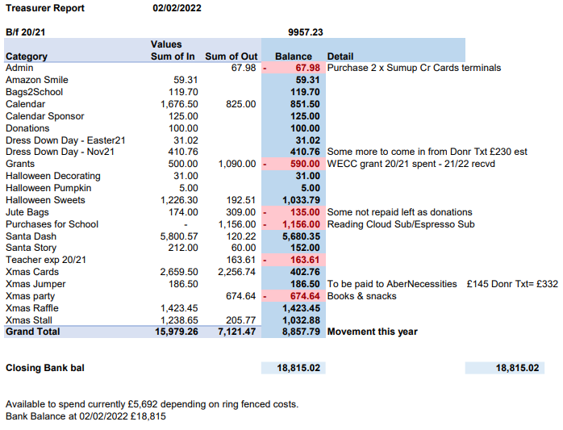
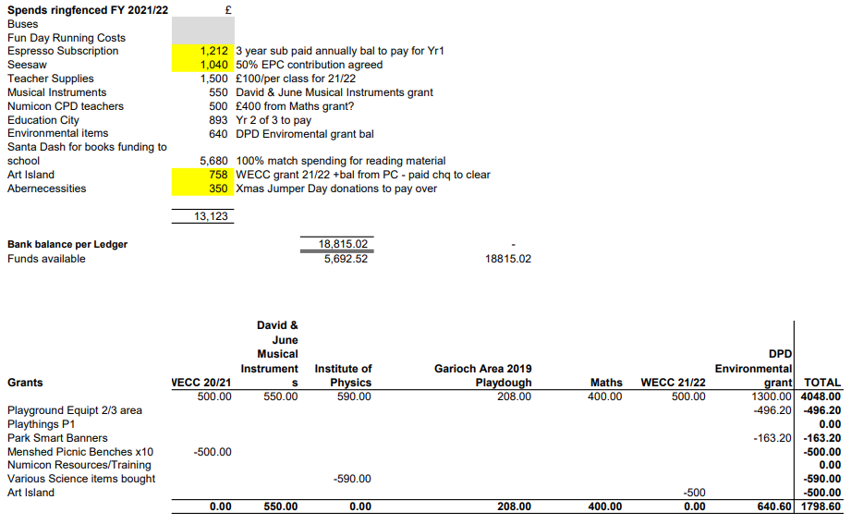

Grants
Adele Megginson briefed group on some potential grants:
Looking to apply to Aberdeen Airport. Persimmon Community Champions and Tesco have also been identified.
We are awaiting response from teachers to know which grants to focus this year and which things to target.

It was also mentioned that the Art island from WECC grant arrived at school. Mrs Thomson said that children had not used it yet, it came without Brushes & Paint Tools and she ordered this last week. £500 received from WECC. PC paid the remaining amount. Awaiting photos from School to submit for WECC bulletin.

Fundraising
CD explained that the following list of events has been proposed. Mrs Thomson commented on a potential overlap with some enterprise ideas that some classes had. It was decided to not go ahead with the Donut day until later in the school year. Smarties will be the easier to plan. Easter egg hunt was suggested during school hours add Mrs Thomson suggestion agreed but confirmed no charges can be made for events that take place during school hours. PC agreed.
CD also informed everyone that our focus to fundraise this year is for technology and we are awaiting a more detailed list of items. As a team we have agreed to organise 1 to 2 events per month, Mrs Thomson agreed.
- Dons Day Out! – Bruce Bain is Happy to organize Proposed date: sat 19th March 2022
- Dress Down Two’s Day, 22 February 2022
- I Love Donut Day, 25th March 2022 – discussed but agreed to postpone as some classes have their own enterprise schemes they will be rolling out at this time
- Smarties or Raisins Challenge, 1st April 2022
- Easter Egg Hunt - TBC
- Spring Disco –TBC (subject to restrictions)
- Dress Down – TBC May 2022
- Fun Day/40th Extravaganza– TBC (subject to restrictions)

Requests for Funding
- Maths text books £1200 – approved, this was the remaining amount from the Santa Dash
- To match funded books £4500 - approved

AOCB
Request for any other business.
Parent queried #1
Is school fun day happening this year? Mrs Thomson explained that they are aware that other schools have advertised dates. We also know we need a minimum 8 weeks to organise an event. Final decisions can only be made as the government updates their guidelines. It does seem very likely that we can hold an event outside, perhaps in June.
Ways you can support your parent council – Attend meetings, Volunteer to run stalls / activities, help with sponsored events, help with social events and become the lead coordinator, share and own any new ideas.

Dates of Next Meetings
April (date tbc) 2022 at 7.00pm via MS Teams, invite for online meeting to be issued in due course.

