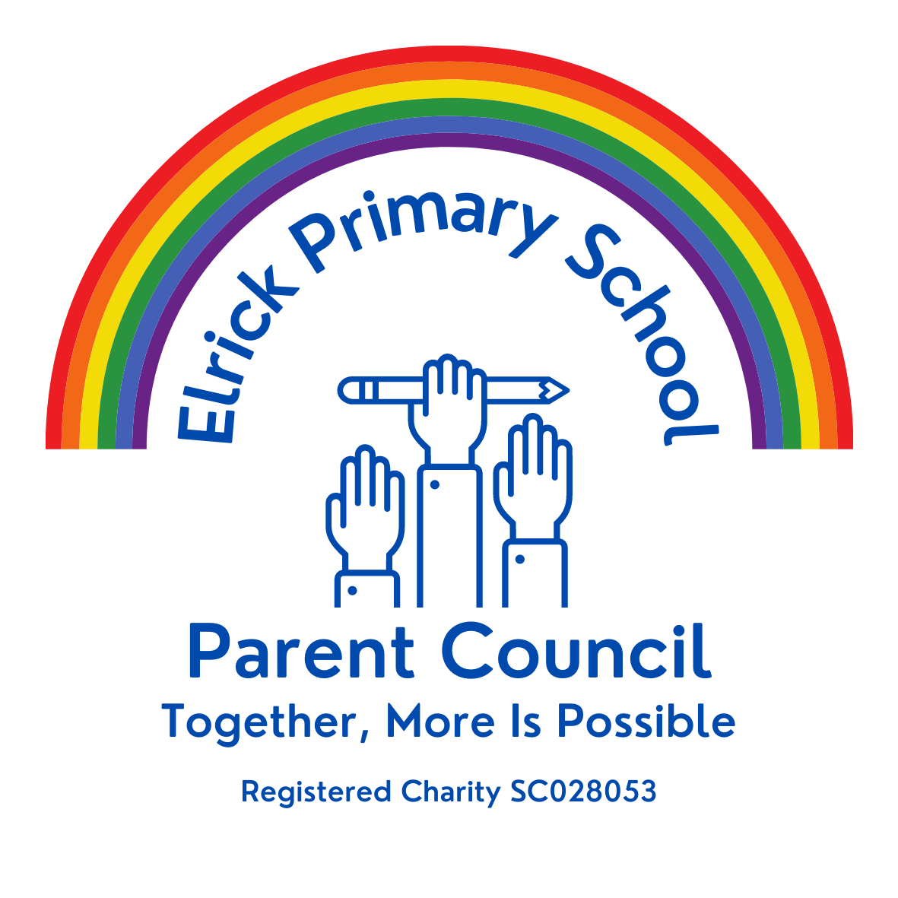
ELRICK PRIMARY SCHOOL PARENT COUNCIL MINUTES
Monday 13th December 2021, 7.00 pm

Location: via Microsoft Teams

Attendees: Christina Daniel (Chair), Jackeline Rodriguez (Vice Chair), Nicola Johnston (Treasurer), Claire Watt (Vice Treasurer), Claire Taylor (Secretary), Adele Megginson (Grants Coordinator), Monique Blair, Fiona Thomson (Head Teacher), Jill Stockdale (Deputy Head), Cllr Alistair McKelvie, Bruce Bain, Helen Ramsay
Apologies: Melody Kuo, Cllr Iris Walker, Cllr Ron McKail, Shalaka Salamant
Review of the Minutes of the Last Meeting & Matters Arising
The minutes were agreed to be accurate.
Ref No | Date Raised | Action | Owner | Status
1119-01 | 12/11/2019 | Wording of Behaviour Policy – all staff have now completed anti-bullying training. Policy review in progress. | Mrs Thomson | Closed
1119-11 | 12/11/2019 | Purchase candy floss machine – no need until we have the opportunity to use | Claire Taylor | On hold
0920-03 | 22/09/2020 | Crisp Bag recycling - Jenny engaging with Eco Committee to ask them to take ownership | Jenny Anderson | Open
1220-02 | 10/12/2020 | Numicon Resources – approx £9200. Grant options to be investigated. | Adele Megginson | On hold
1220-03 | 10/12/2020 | Advise David and June Gordon Memorial Trust of the delay in purchasing the outdoor instuments. JA to go ahead and order from TTS. | Jenny Anderson | Open
0221-01 | 04/02/2021 | Advice WECC on the status of the spend of their £500 donation towards picnic benches. Benches received. Photos to be sent to WECC after installation. | Fiona Thomson | Open
0521-04 | 06/05/2021 | 40th Anniversary Afternoon Tea – look at venues and available dates | Christina Daniel/Nicola Johnston | On Hold
0621-01 | 17/06/2021 | Elrick Extravanganza – Fiona to set up a sub group to organise – postpone to 2022 | Fiona Fitzgerald | On hold
06/21-02 | 17/06/2021 | Playground Resurfacing – look for a volunteer to lead on fundraising | Christina Daniel | On hold
10/21-01 | 11/10/2021 | 40th Anniversary Recipe books- to be completed as a homework | Fiona Thomson/All Staff | Open
09/21-02

Welcome and PC Update
I would like to welcome and extend warm greetings to you all for joining us tonight. Past couple of months have been extremely busy for us as a new team as we have been extremely busy planning and preparing for fundraising and community events which I will share with you later on.
We have also focussed on how to increase our engagement with parents and broader community through social media and we have been quite successful.
I am also bursting with happiness as I have an extremely exciting news to share on behalf of everyone is that we have raised £5150 for Santa Dash! Yay!!!! Our goal was £2000 to be matched fund
We have now more than £5000 to match fund for reading resources. Thank you so much to everyone who donated, thank you to kids who raised this amount. To all the volunteers who helped, to all the staff making it possible. Last but not least a huge thank you to Mrs Thomson for arranging a match funding for us!

Head Teachers Report
Purpose of the Report
The purpose of the report is to update the Parent Forum on key areas at Elrick School. This will include staffing, learning and engagement, school improvements, reporting to parents, and any other relevant information.
Staffing
There have been no changes to staffing since the October update. As has been the case with most schools we have had more frequent staff absences to deal with and we appreciate everyone’s patience and understanding.
School Improvements
Building
The school roof is now complete, and we are delighted with the standard of the work, holding up to the recent adverse weather with no evidence of any leaks or damage.
Learning Estates and Property have been out to inspect the learning environment and have advised of further school improvement. Architects and surveyors are drawing up plans which will be shared with the school community in due course.
I have expressed that we would welcome better outdoor provision, such as MUGA. Funding for this needs to be explored as with the Free School Meals expansion, they are looking at ways to provide alternative sports provision to accommodate an increase in school lunches. I will update everyone as soon as I have any more information to share.
Learning and Engagement
The initial inspection visits for both the Wellbeing Award and Leading Parental Partnership Award have both been completed, and we are now in the process of finalising an action plan for each area. This is done in collaboration with the Award Advisor and will be shared on our website when completed.
The initial visits were very positive, and the advisor identified many strengths with existing practice as well as key areas for development.
LPPA –
Strengths
- Commitment of SLT to work with and engage the parent body
- Proactive approaches
- Current monitoring and reporting systems
- Induction and transition processes
- Access to resources and support
Area for Focus
- Objective 4
The school promotes the awareness and participation of all groups of parents in supporting their children’s learning and developing their own learning. In addition, the school holds and actively promotes a programme of opportunities and events for joint parent and child participation.

WAS –
Strengths
- Leaders are fully committed to ensuring the emotional wellbeing and mental health of all of the school community.
- The school already provides a range of support for the emotional wellbeing and mental health (EWMH). The school has a clear vision of how it wants to develop this in the future, with the Wellbeing Award being used to help this vision become a reality.
- Staff are positive and nurturing of the pupils.
- Key staff have been provided with training about aspects of mental health.
- The school already has systems in place to identify the need for support and to respond effectively.
- The school already has a health committee in place and this group will actively contribute to the WAS.
- The school has well-developed links with other schools and external agencies.
Area for Focus
- To embed a strategy for promoting positive emotional wellbeing and mental health which is shared and understood across the school community.

The school will engage in regular evaluation, using a variety of methods to gather feedback from stakeholders which will be used to inform future development and plan next steps.

Pupil Council
We have a very healthy pupil council with 23 representatives from P4-7. Office Bearers have been elected as follows:
Sophie Cartlidge (CHAIR)
Isabella McAulay (VICE CHAIR)
Rhys Allan (SECRETARY)
Sophie Johnston (VICE SECRETARY)
Discussion and suggestions raised from classes included:
Purchasing more textbooks to support learning (P7)
Consider extending ‘Santa dash’ idea to Halloween, Easter etc
Purchase more Ipads
Contact authority regarding the condition of the toilets in P1/2 area and P6/7 area
Support Parent Council to organise a spring fayre/fun day
Plan an Elrick Talent Show
Re-introduce playground buddies
Create a wall display to advertise work of pupil council and share key information and dates
Encourage suggestions from classes through a ‘suggestion box’
Pupil Council to present at assembly and share key information through school newsletter and website
Look at ways to promote our updated school values – KIND, RESPECTFUL, SAFE
- The Pupil Council Agenda and Minutes will be uploaded on to our school website for everyone to share
In-Service/Collegiate
During the November in-service days, staff have been involved in the following training: -
Whole School Nurture;
Sensory Processes and Creating Effective Sensory Environments (NHS);
Paediatric First Aid;
Dyslexia/Autism Awareness.

Parental Engagement
As part of being a parent at Elrick School we try to provide a range of opportunities for you to find out about your child’s learning both as an individual and as part of their class. We can’t wait until we can invite our parents to join us face to face for these meeting but at the moment the guidance still does not permit this to happen. We will update you as and when this changes but please don’t ever think that we are not here to help. If you need to speak to a member of staff, please contact the school office (01224 472910) or email the staff member to organise.
Welcome to Elrick
We have uploaded a new video to our website to introduce our updated Values, Vision and Aims. We are in the process of working with IT to try and get this embedded on to the home page so that it is easier for parents to access.
Promoting Positive Relationships and Anti-Bullying
Thank you to everyone who attended our parent session on ‘Promoting Positive Relationships and Anti-Bullying’ in November. We are planning to share the presentation on our school website for those who were unable to attend and would appreciate feedback through the Microsoft Form included at the end of the presentation.
Family Learning
I have added a new tab on our school website to support Family Learning. On here you will find resources and links to support learning at home, including information on how to use ‘Read, Write, Count’, ‘Bookbug’ and links to Aberdeenshire Educational Psychology Service.
Annual Reports and Parent Evenings
Thank you to everyone for engaging with our Parent consultation evenings in Term 1/2. Our annual reports will be issued prior to the Easter holidays as well as a further opportunity to meet with the teacher to discuss your child’s progress. We would encourage ALL parents to engage with this opportunity as it is as important to share their progress and strengths as well as finding out any areas for development and agree appropriate next steps.

COVID update
We have been fortunate this term that our confirmed cases of COVID have remained quite low. However, we do recognise that it is still very prevalent in our local community and that many families and workplaces are still being impacted.
Thank you to all of our families for following the Government Guidance and helping us to maintain a healthy and safe school environment. We know that it can be quite confusing as the advice is updated and changed quite frequently. Please just call and ask if you have any queries and we will do our best to help you or signpost you in the right direction at least.

Items raised by Class Reps
School Performances
We are as disappointed as everyone else that we are not allowed to have parents into school to watch Christmas Performances. We know it is causing some upset, especially when larger public gatherings and sports events are permitted but unfortunately the decision is out with our control, and we must follow Government Advice.

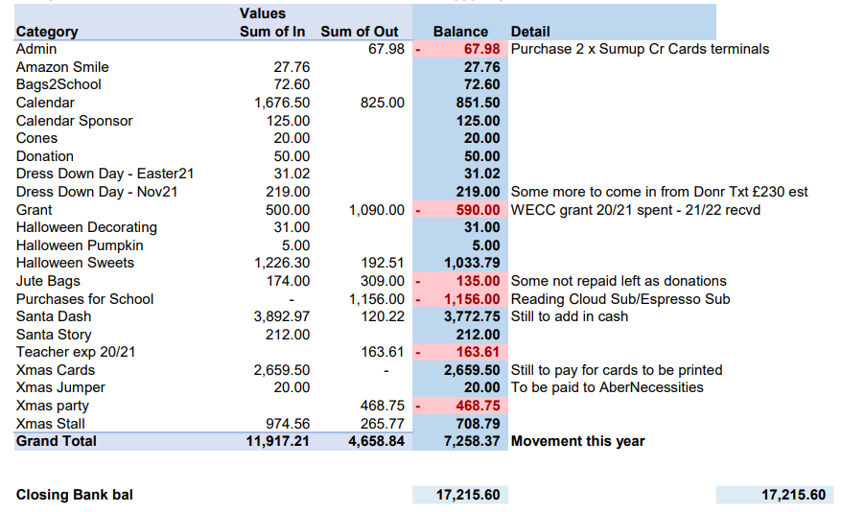
Financial Report

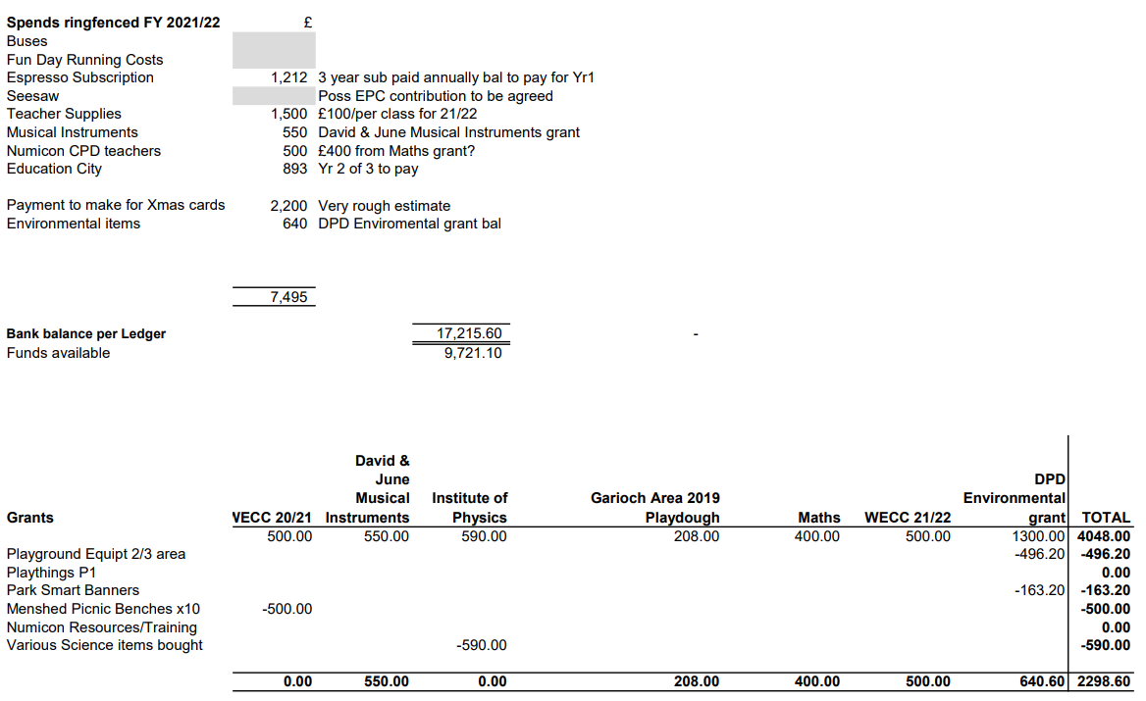

Grants
WECC’s Community Support Fund. Application submitted on 8th October, 2021. Awarded on 18th October
£500 cheque to help fund the purchase of an Art Island, total cost £758
Pending - Order equipment remaining funding required £258?
Update Wishlist of teachers, meeting with them would be helpful to provide focus of what grants to apply for.
Will be sending them an email/survey shortly, to get feedback.

Fundraising
Achieved
- Successful Spooky Halloween Stall - Received overwhelming response, kids and parents want us to do this again. Sold out both days in less than half an hour!
- Pumpkin Carving Contest
- Halloween Decoration Contest
- Dress Down Day Inspired by Guy Fawkes Night
- Ashdale Hall Christmas Fayre
- School Calendar
- Christmas cards
- Ashdale Hall Christmas Fayre - Amazing team effort, lots of donations received. So good to see people feeling Christmas Spirit. We offered free tea coffee along with home bakes for anyone struggling with power cuts Post Storm Arwen in Westhill, we received appreciation for helping the community. In the time of need! It was very well received.
- Story with Santa – lots of lovely feedback
- Santa Dash
- Christmas Raffles –Online Draw on 16th Dec
- Christmas Dress Down Day raising money for Abernecessities.
- A Super Special Surprise for kids on 16th Dec from PC (Can’t disclose much info just yet)
A special thank you to our wonderful fundraising volunteers who made all of our October, November and December events and initiatives possible.
As always we are truly overwhelmed by the generosity of Local businesses and Scottish Parliament who have went above and beyond to support our Christmas Raffle this year.
To our children – your smile and happiness means a lot!
And last but not least our incredible staff of Elrick Primary for their continued support.

Requests for Funding
- Annual subscription for £20 lotteries license - Approved
- Annual subscription for Discovery Education Espresso, balance to previously paid, £1212 - Approved
- Amazon shopping list against grant, £590 – Approved
- Contribution towards Seesaw subscription, total cost £2080 – Approved £1040
- Running costs of Christmas initiatives £850 – Approved
- To complete purchasing of Art Island £258 - Approved

AOCB
Easy Fundraising
Easyfundraising turns your everyday online shopping into free donations for your favourite cause. Just start your online shopping first at easyfundraising, then shop as normal. Retailers will then make a small donation to say “thank you”.
Amazon Smile
PC receive 0.5% of your total spend at no cost to you
Bag2School
The school benefits from a cash rebate
Mynametags
24% of your total spend will be donated to our funds

Dates of Next Meetings
Thursday 03 February 2022 at 7.00pm via MS Teams

