ELRICK PRIMARY SCHOOL PARENT COUNCIL MINUTES
Monday 11th October 2021, 7.00 pm

Location: via Microsoft Teams

Attendees: Christina Daniel (Chair), Jackeline Rodriguez (Vice Chair), Nicola Johnston (Treasurer), Claire Watt (Vice Treasurer), Claire Taylor (Secretary), Adele Megginson (Grants Coordinator), Lauren Wade, Monique Blair, Fiona Fitzgerald, Shalaka Samant, Santana Kidd, Fiona Thomson (Head Teacher), Jenny Anderson (Depute Head Teacher), Cllr Iris Walker, Cllr Ron McKail
Apologies: Donna Snowie, Melody Kuo, Bruce Bain
Review of the Minutes of the Last Meeting & Matters Arising
The minutes were agreed to be accurate.
Ref No | Date Raised | Action | Owner | Status
1119-01 | 12/11/2019 | Wording of Behaviour Policy – all staff have now completed anti-bullying training. Policy review in progress. | Mrs Thomson | In progress
1119-11 | 12/11/2019 | Purchase candy floss machine – no need until we have the opportunity to use | Claire Taylor | On hold
0920-03 | 22/09/2020 | Crisp Bag recycling - Jenny engaging with Eco Committee to ask them to take ownership | Jenny Anderson | Open
1220-01 | 10/12/2020 | Institute of Physics Grant still to be spent. Requisition request completed. | Fiona Thomson | Closed
1220-02 | 10/12/2020 | Numicon Resources – approx £9200. Grant options to be investigated. | Adele Megginson | Open
1220-03 | 10/12/2020 | Advise David and June Gordon Memorial Trust of the delay in purchasing the outdoor instuments. JA to go ahead and order from TTS. | Jenny Anderson | Open
0221-01 | 04/02/2021 | Advice WECC on the status of the spend of their £500 donation towards picnic benches. Benches received. Photos to be sent to WECC after installation. | Fiona Thomson | Open
0221-04 | 04/02/2021 | Start advertising 40th anniversary and look at current pupils interviewing former pupils (merged with the recipe book action below) | Christina Daniel | Closed
0521-04 | 06/05/2021 | 40th Anniversary Afternoon Tea – look at venues and available dates | Christina Daniel/Nicola Johnston | On Hold
0621-01 | 17/06/2021 | Elrick Extravanganza – Fiona to set up a sub group to organise – postpone to 2022 | Fiona Fitzgerald | Open
06/21-02 | 17/06/2021 | Playground Resurfacing – look for a volunteer to lead on fundraising | Christina Daniel | Open
10/21-01 | 11/10/2021 | 40th Anniversary Recipe books- to be completed as a homework | Fiona Thomson/All Staff | Open
09/21-02

Welcome and PC Update
On Behalf of everyone I take this opportunity to warmly welcome you all to our PC meeting, specially to any new parents who have joined us tonight. What busy couple of weeks these have been for me and for all the office bearers of 2021/2022, but we have learnt so much and still learning new things every day. In addition to our elective members in AGM we have a little update tonight as Adele Megginson who joined us as an ordinary member has taken on the Grants coordinator role now. Santana Kidd has joined us as an ordinary member this month. Along with Facebook, we are on Twitter and Instagram now, also have our very own PC logo.

Head Teachers Report
The purpose of the report is to update the Parent Forum on key areas at Elrick School. This will include staffing, learning and engagement, school improvements, reporting to parents, and any other relevant information.
Staffing
We are delighted to welcome Lynsey Milne and Hannah Massey to the Elrick Staff. Lynsey and Hannah have started in their roles as Pupil Support Assistants. This has been funded by the Scottish Government Funding and they will be providing targeted support until 31st March 2022.
We are also delighted to have Mrs Claire Beltran join us in the P1/2 department. Mrs Beltran (EYP) has been supporting the transition from nursery to P1 and has been a tremendous help to staff and pupils as they continue to develop and embed play based pedagogy into the Early Years’ curriculum.
Mrs Beltran’s post in nursery is now being covered by Mr Michael Emery. Mr Emery started with us last week and we are delighted to have him join our nursery team. This post is also being funded by the Scottish Government with funding in place until 31st March 2022.
Mrs Stockdale will be returning after the October holidays and is very much looking forward to working with everyone again. She will be picking up her class commitment in P5 with Miss Horner from week beginning Monday 1st November. I would like to thank Mrs Moir for all her support in P5 this term! Mrs Moir will continue to provide ‘additional support for learners’ while Mrs Stockdale phases back to her full hours.
We are also delighted to advise that Mrs Lauren Carroll (P1C) is expecting her first baby in April 2022. Congratulations to both Mr and Mrs Carroll. All being well, Mrs Carroll plans to remain in class until the end of Term 3.

School Improvements
Building Works
The school roof work is due to be completed prior to return on the 1st November 2021. We are delighted with the standard of the work to date and are very much looking forward to having it completed and getting our school grounds back to normal. I would like to thank all our staff and families who have been incredibly patient and understanding with the disruption caused by this work. It has not been an easy way to start the school year, but the work was definitely long overdue, and I am confident the impact will be positive moving forward.
Aberdeenshire Council’s building surveyor and Learning Estates Team will be visiting Elrick School to evaluate the work and investigate any further repairs that may now be needed (i.e., internal ceiling damage).

Learning and Engagement
Work is now underway for both the Wellbeing Award and Leading Parental Partnership Award and stakeholder evaluations have been issued. We would be very grateful if everyone could take 5 minutes to complete these as this then provides us with the information required to create our action plans and steer the direction for moving the school forward in both these areas. We have had several parent volunteers but would be delighted to have a few more. Please contact Fiona.J.Thomson@aberdeenshire.gov.uk if you are interested.
We are delighted to have our CLANS established and were very proud of all those P7 pupils who put themselves forward for ‘Clan Chief’. The children were asked to prepare a short presentation which they shared with pupils and staff. The children and staff then had to vote for their preferred candidate. The following pupils were appointed:
Bennachie – Jessie Coutts and Christina Charles
Eagle – Shae Davidson and Grace McLeod
Ness – James Snowie, Zoe Milne and Sophia Frain
Thistle – Melissa Hunter and Katie Goldie
We now have our ‘Digital Leaders’ in place and they will be supporting staff and pupils to develop and embed digital technology across the school. More information will follow as the group gets established.
Adverts for our Pupil Council will be issued to classes this week and we are encouraging pupils who are interested from P4-7 to submit a short Personal statement to include the qualities and characteristics they hold that would make them a suitable candidate for the role. We will then elect ‘Office Bearers’ in a similar way to the Parent Council.
Class Teachers have also been very busy this term. Planning and Assessment are always a key focus for Term 1 and staff have been engaging with SLT to quality assure the systems and support we have in place around these. We have also had collegiate sessions on ‘Digital Literacy’, ‘Meeting Support Needs’ and ‘Making Thinking Visible’.
We have new science resources that have arrived and staff have had the opportunity to explore these. Thank you to Mrs Young and Mrs Duncan for their support with this.

Reporting to Parent Opportunities
As part of being a parent at Elrick School we try to provide a range of opportunities for you to find out about your child’s learning both as an individual and as part of their class. We can’t wait until we can invite our parents to join us face to face for these meeting but at the moment the guidance still does not permit this to happen. We will update you as and when this changes but please don’t ever think that we are not here to help. If you need to speak to a member of staff, please contact the school office (01224 472910) or email the staff member to organise.
- Thank you to everyone who attended the ‘Meet the Teacher’ virtual sessions in August/September.
- Parent consultation meetings started last week and are ongoing through Teams – we are exploring the use of a ‘Parent booking’ system to help streamline the process for booking these appointments in the future.
- We have now re-established Seesaw as a tool for sharing learning between home/school and are delighted with the quick uptake from parents. – thank you!

COVID update
We have been fortunate this term that our confirmed cases of COVID have remained quite low. However, we do recognise that it is still very prevalent in our local community and that many families and workplaces are still being impacted.
Thank you to all of our families for following the Government Guidance and helping us to maintain a healthy and safe school environment. We know that it can be quite confusing as the advice is updated and changed quite frequently. Please just call and ask if you have any queries and we will do our best to help you or signpost you in the right direction at least.

Financial Report
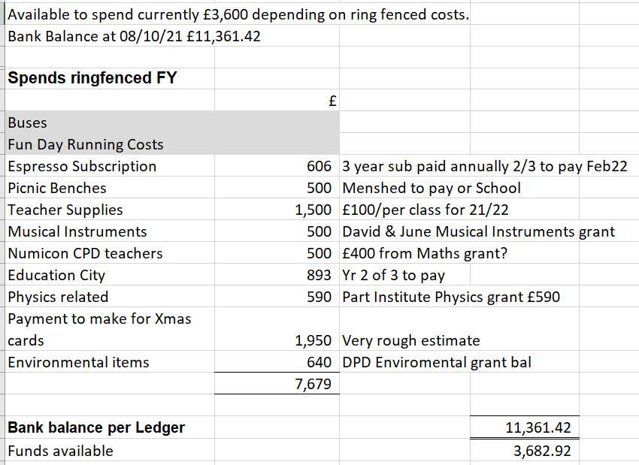
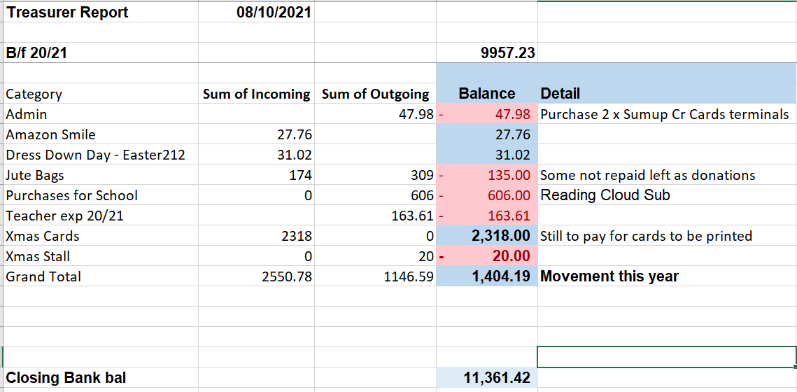

Grants
Adele Megginson was nominated for Grants Co-ordinator by Christina Daniel; this was seconded by Claire Taylor.

WECC application has been submitted and we await feedback. This was based on the purchase of an Art Island. Identified by the staff members this would provide a good opportunity for P1- P3. It allows multiple users. Can be used as a whiteboard, has a magnetic element meaning the children can attach paper and use the island for painting, pen and other mediums. Planned to be placed in a shared area where pupils would benefit from it. Cost of Ex VAT is £758.

Fundraising
- Survey Aim
Interest in getting parental viewpoints on the following. How parents would like funds to be prioritised when budget is stretched. Decide on key fundraising events that will be supported by parents/carers and children. Annual monetary donation. Parent council meeting most voted time. This honest viewpoint (anonymous) was open from Thursday 23rd Sept to 30th Sept. Multiple-choice questions.

- As parent council we fund the following annually in addition to bigger ticket items that school request…., what do you think we should not fund? 1 Christmas Party (48 votes) 2 Bus Trips (36 votes) 3 Education City (18 votes)
- What do you think PC funds should be spent on? What should we aiming to improve for your child's education? Now the focus is on outdoor learning, but we would love to hear your thoughts….,
I’m satisfied that the funds are spent effectively at present.
Resources for the highest - needed kids. Coding equipment.
Input/thoughts from teachers, PSAs, and Children Excursions for the pupils.
Concerns raised around school’s condition.
Mental Health, Bullying (Cyber), mindfulness, Road safety, police visits, Diversity.
More money should be put into reading resources/online library.

Key events that will be supported are: 1. Christmas Fayre 2. Fun Day 3. Dress Down Dress. This shows that over half of responses are willing to support key initiatives, like annual donation. We will also be using the comments and suggestions to further improve the fund spent & school in the future.

- Halloween
Spooky Halloween Stall this Thursday & Friday 14 & 15th We have received donations from Tesco, Morrisons, M&S, Co-op, and office bearers
Pumpkin Carving Contest from 11th Oct to 4th Nov, Free entry (Initiative to support the community)
Dress Down Day Date 5th November 2021 Theme: to coincide with Guy Fawkes Night
Halloween Decoration Contest 15th Oct-2nd Nov Judged by Cllr Ron McKail

- Christmas
Stall taken at the Ashdale Hall Christmas Fayre 28th November 10am – 4pm. We are looking for support on the day and ideas of what to sell.
Calendar is being prepared and staff were asked to ensure all drawings are gathered and returned to school office for the end of term.
Christmas Jumper day will be 16th December to coincide with school Christmas Lunch, with all funds raised going to Save the Children.
Christmas Raffle, we are looking for prizes to be donated.
All completed Christmas Cards templates are being collated with 5 that we are trying to source the artist and a reminder email has been issued to some. It is important that all payments are finalised by 15th October.
Reindeer Run for kids, with their age = laps around the playground, this would be completed during school time. Antlers to be provided and children will look for sponsorship from family and friends.

Requests for Funding
- Ashdale Hall Christmas Fayre stall - £20 – approved
- Contactless Card Reader (SumUp) for payments at events – 2 at £23.99 each – approved
- Class teacher funding – 18 at £100 each – approved
- Outlay for Halloween Tuck Shop - £200 – approved (profit of £1000)

Westhill Cluster Winter Clothing Swap
The Westhill cluster of primary schools came together for this initiative. A great way for clothing to be reused rather than recycled. All surplus stock and £40 was donated to Abernecessities and a donation of £75 was made to the Ashdale Hall for allowing us to use the facility for free. Funds were raised from the donated home bakes, Tea and coffee that we sold.

Items Raised via Class Reps
- Could consideration be given to giving a full week to complete homework ie issued on a Monday for the following Monday
- FT to pass this on to teachers for discussion. Most teachers prefer time in between to enable them to mark and evaluate progress before planning the next tasks.
- Could a reminder be given to parents driving to school to not drive along the pavement to park. This makes it extremely dangerous for children walking along the pavement to get to school.
- We are very aware of the parking issues and have put out several emails to parents as there have been a few ‘near misses’. We have also been in touch with Police Scotland and are hoping for more regular police presence/drive bys at key school times. We have also been in touch with Joanna Stewart, Aberdeen shire Council for strategic planning support (eg., school travel planners, educational visits).
- Will there be Bikeability this year
- We have been discussing Bikeability and the practicalities around this. Now that we have the end of the building works in sight and the updated guidance about volunteers it is more possible as volunteers are permitted for outdoor support. There is still a hold on PVG applications which may hinder planning. At the moment we do not have staff capacity to do this without a number of parent volunteers as DHTs class committed and staff absences are more frequent due to COVID testing. Our priority must be ensuring every class has a class teacher.
- Will there be swimming sessions for P6 this year
- There has been no update regarding this. Struggled to get any spaces last year for children with support needs due to back log. FT will investigate further and update next term.
- Is the Ski trip going to be going ahead?
- No. We have made the decision to priorities our P7 residential this year. An email has gone out to our P6 families. There are still concerns around COVID and cancellations and the council insurance policy are not valid in these circumstances. In addition, staff absences are still frequent, and cover is challenging to secure.

AOCB
None

Dates of Next Meetings
Thursday 9th December 2021 at 7.00pm via MS Teams

