ELRICK PRIMARY SCHOOL PARENT COUNCIL MINUTES
Wednesday 8th September 2021, 7.30 pm

Location: via Microsoft Teams

Attendees: Christina Daniel (Chair), Jackeline Rodrigues (Vice Chair), Nicola Johnston (Treasurer), Claire Watt (Vice Treasurer), Claire Taylor (Secretary), Lauren Wade, Monique Blair, Fiona Fitzgerald, Shalaka Samant, Faye McDonald, Mandy Mackintosh, Freya McKenzie, Laura Black, Judith MacDonald, Susan McLean, Vikki Bowron, Santana Kidd, Fiona Thomson (Head Teacher), Jenny Anderson (Depute Head Teacher), Leah Robinson (Depute Head Teacher), Shareen Horner (Principal Teacher), Cllr Alastair McKelvie
Apologies: Donna Snowie, Melody Kuo, Lana van der Toorren, Cllr Ron McKail, Cllr Iris Walker
Review of the Minutes of the Last Meeting & Matters Arising
The minutes were agreed to be accurate.
Ref No | Date Raised | Action | Owner | Status
1119-01 | 12/11/2019 | Wording of Behaviour Policy – all staff have now completed anti-bullying training. Policy review in progress. | Mrs Thomson | In progress
1119-11 | 12/11/2019 | Purchase candy floss machine | Claire Taylor | On hold
0920-03 | 22/09/2020 | Crisp Bag recycling - investigate as to why this isn’t working. Jenny to look for a volunteer teacher to take this on. | Jenny Anderson | Open
1220-01 | 10/12/2020 | Institute of Physics Grant still to be spent. Requisition request completed. | Fiona Thomson | Open
1220-02 | 10/12/2020 | Numicon Resources – approx £9200. Grant options to be investigated. |  | Open
1220-03 | 10/12/2020 | Advise David and June Gordon Memorial Trust of the delay in purchasing the outdoor instuments. JA to go ahead and order from TTS. | Claire Taylor/Jenny Anderson | Open
0221-01 | 04/02/2021 | Advice WECC on the status of the spend of their £500 donation towards picnic benches. Benches received. Photos to be sent to WECC after installation. | Claire Taylor/Fiona Thomson | Open
0221-04 | 04/02/2021 | Start advertising 40th anniversary and look at current pupils interviewing former pupils | Christina Daniel | Open
0521-01 | 06/05/2021 | Investigate grant applications for gardening and eco projects – Tesco grant applied for. | Fiona Fitzgerald | Closed
0521-04 | 06/05/2021 | 40th Anniversary Afternoon Tea – look at venues and available dates | Christina Daniel/Nicola Johnston | On Hold
0621-01 | 17/06/2021 | Elrick Extravanganza – Fiona to set up a sub group to organise | Fiona Fitzgerald | Open
06/21-02 | 17/06/2021 | Playground Resurfacing – look for a volunteer to lead on fundraising | Christina Daniel | Open
09/21-01
09/21-02

Head Teachers Report
Mrs Thomson shared a presentation “Standards and Quality Report and Improvement Plan”
Contained in Appendix A
Financial Report
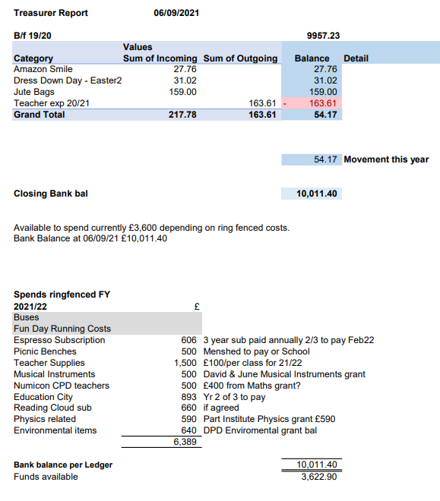

Grants
On hold pending appointment of new Grants Co-ordinator

Fundraising
- Fundraising Questionnaire
Your new Parent Council are keen to prepare and issue a google form to try and get some feedback on what sort of fundraising ideas you would like to see run. You might have some new ideas as well. That will help us focus our attention and develop an events list for the school year.

- Westhill Market
There are regular Westhill markets at Ashdale hall and anyone can take a stall. We would consider doing this if we are unable to host something within school. This will depend on the timing of restrictions being lifted. Another consideration was to host a small ‘Outside Christmas Fayre’.

- Halloween Disco
This will depend on the timing of restrictions being lifted. Another consideration was to host a small ‘Outside Halloween Disco.’

- Christmas Cards and Gifts
Work has started on the distribution of Christmas Card templates, these will soon be sent home and we will look for them to be returned to school prior to the October holidays.

- Calendar
We have 3 amazing volunteers to try and get a school calendar prepared and ready for sale. We know how much you missed it last year.
- Krispy Kreme Doughnuts
This is a fundraising initiative where we buy at a reduced rate and sell on, it was discussed that this could be something we could add as a stall to a fayre or could be held on last day of term.

- The Handy Solution Sanitizing Gel / Fab Bricks
Both are good fundraising small gifts, hand sanitiser, key rings etc. they would be good for a stall at a fayre.

- WECC Community Support Fund
We need a volunteer to submit an application for the WECC grant, deadline is 8th October and application is generally very straight forward to do.

Requests for Funding
- Reading Cloud Subscription - £660 – approved

Westhill Cluster Winter Clothing Swap
The Westhill cluster of primary schools are arranging a ‘Winter Clothing Swap’ to be held at Ashdale Hall on Sunday 10th October 12 – 3pm. Any parents can come along and can swap or simply take any items that can make use of in the next size up! We will look for donations in the lead up to and some volunteers to support on the day.

School Website Update
Parent Council requested support from school to update their area on the school website. School confirmed we should contact Mrs Carroll direct for this.

Items Raised via Class Reps
2021/22 Occasional Days
A lot of feedback was given from parents that the 2 occasional days which have been added to the start of this year’s Christmas holiday, was not an ideal time for parents, causing problems with the lack of child care options and not having the sufficient holidays left from their own employers to be able to cover. It seemed to had been decided at very short notice. Parents would like the opportunity to vote their preference in future.

School advised this was a cluster school vote and that on this occasion they did not have the time to canvass parent opinion. They also confirmed that this was not what they voted for and will wherever possible request parent input in future decisions.

Lack of stools/chairs
There is no lack of chairs / stools. Some classes have been learning about the different types of office spaces / work places and have been experimenting by using all different styles of chairs for different tasks, to see what suits best. This includes the like of camping chairs. This is encouraging children to think for themselves and be open to different ideas and approaches. These classes have now had this information shared via their meet the teacher.

AOCB
P7 Leavers Hoodies
P7 hoodies are being looked at just now. The cluster schools have agreed to issue at the same time. Consideration will be given as to whether this can be sooner, as parents find themselves spending money on items that the children then don’t get the wear out of. A point to note from school was that they try to account for children joining later into P7 and ensure they include everyone where possible.
There was a parent suggestion that we could use local business Black Bear Designs. School have used them for products previously and will review there pricing and availability.

Covid Guidance
Elrick’s guidance and risk assessment is up to date and can be found on their website. Staff are familiar with the extended list of symptoms and are working with parents on an individual basis when the need arises.
There is no change to the rules that were in place before the summer holidays.

P7 Bikeability
School are reviewing the possibility of hosting Bike ability this year. If able to do so they will look to cover both age groups but will be reliant on parent volunteers.

Dates of Next Meetings
Monday 11th October 2021 at 7.00pm via MS Teams

