ELRICK PRIMARY SCHOOL PARENT COUNCIL ANNUAL GENERAL MEETING (AGM) DRAFT MINUTES
8th September 2021, 7.00 pm
Location: Microsoft Teams
Attendees: Claire Taylor (Chair), Lauren Wade (Vice Chair), Nicola Johnston (Treasurer), Monique Blair (Secretary), Christina Daniel (Fundraising Co-Ordinator), Fiona Fitzgerald (Grants Co-ordinator), Shalaka Samant, Faye McDonald, Mandy Mackintosh, Freya McKenzie, Laura Black, Judith MacDonald, Susan McLean, Vikki Bowron, Santana Kidd, Jackeline Rodrigues, Claire Watt, Fiona Thomson (Head Teacher), Jenny Anderson (Depute Head Teacher), Leah Robinson (Depute Head Teacher), Shareen Horner (Principal Teacher), Cllr Alastair McKelvie
Apologies: Donna Snowie, Melody Kuo, Lana van der Toorren, Cllr Ron McKail, Cllr Iris Walker
Review of the Minutes of the Last AGM on 22 September 2020 & Matters Arising
None
Chairperson’s Report for 2020/21
And here we are at another AGM, this year sped past me, feels like a whirlwind!
So, let’s just take a minute to stop and think about what we set out to do in the school year, what we have achieved and what we are still trying to get after.
Our vision was to strengthen our school community; raise funds for the extras for our children; be a bridge between parents and school.
- Dress Down Rainbows and Smarties
- Smartie's challenge
- Pumpkin Treasure Trail
- Pumpkin Carving
- Christmas Cards
- Rag Bin / Bags 2 School
- Road Safety week and pupil’s banners competition
- Nursery parent focus group
- Virtual Very Merry Christmas Fayre
I want to close by thanking Elrick Senior Management team, all the teaching and support staff. You have been amazing and supportive in embracing our initiatives, I feel we have a strong and trusting repo ire, but I guess we are all ultimately aiming to achieve the same goal.
To my phenomenal team of office bearers for keeping me sane and steering me when I stray or go off on a tangent with random ideas! Our class reps for humoring me and sharing all our requests with their groups.
Lastly my biggest thanks goes to the parents and carers for supporting us and getting involved, how lovely it is to see some many new faces (okay names!) on tonight’s call.

Approval of Accounts for Year Ending 30 June 2021
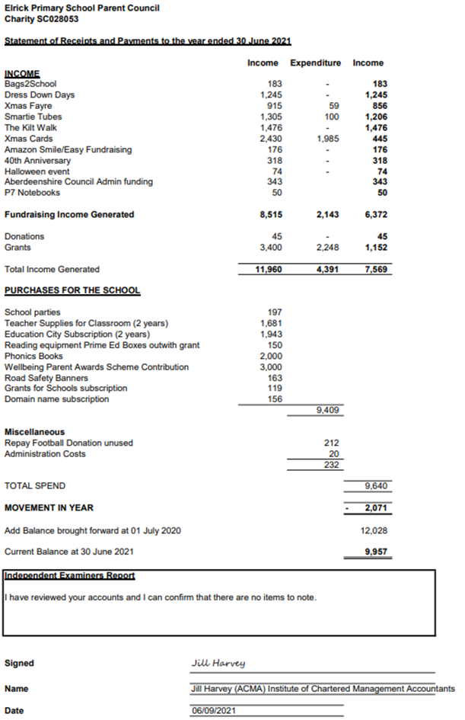

Appointment of Independent Examiner
Jill Harvey (ACMA) Institute of Chartered Accountants, has audited the accounts. This is required before they are submitted to the Office of the Scottish Charity Regulator (OSCR) as we are a registered charity.

Election of Office Bearers 2021-2022
The following Office Bearers were nominated for the academic year 2021-2022. There was only one nomination for each position, so no vote was required.
All present agreed to elect as below.
Post | Name(s) | Nominated/Seconded
Chair | Christina Daniel | Fiona Fitzgerald/Shalaka Samant
Vice Chair | Jackeline Rodrigues | Fiona Thomson/Shalaka Samant
Treasurer | Nicola Johnston | Claire Taylor/Fiona Thomson
Vice Treasurer | Claire Watt | Fiona Thomson/Christina Daniel
Secretary | Claire Taylor | Nicola Johnston/Fiona Thomson
Grants Co-ordinator
Fundraising Co-ordinator
Ordinary Members | Melody Kuo  Shalaka Samant  Lana van der Tooren  Adele Megginson | Christina Daniel/Claire Taylor  Christina Daniel/Claire Taylor  Claire Taylor/Christina Daniel  Claire Taylor/Christina Daniel

AOCB
None

