**ELRICK PRIMARY SCHOOL PARENT COUNCIL MINUTES**

**Wednesday 13th May 2020, 6.30 pm**

Location: via Skype

Attendees: Claire Taylor (Chair), Fiona FitzGerald (Vice Chair), Monique Blair (Secretary), Lauren Wade (Treasurer), Nicola Johnston, Lesley Davie, Christina Daniel, Mrs Fiona Thomson (Head Teacher), Miss Jenny Anderson (Depute Head Teacher), Cllr Ron McKail, Cllr Alistair McKelvie

Apologies: Bruce Bain, Alessandra Savassi, Cllr Iris Walker

**Approval of March Meeting Minutes**

The minutes were agreed to be accurate.

**Review of Actions from March Meeting**

* 1119-01 Behavior Policy – work on this is ongoing virtually with all staff and will continue next session.
* 1119-03 Respect Me – Mrs Thomson has already been on this course. Will be further progressed once schools reopen.
* All other actions carried forward due to lockdown.

**Treasurer’s Report**

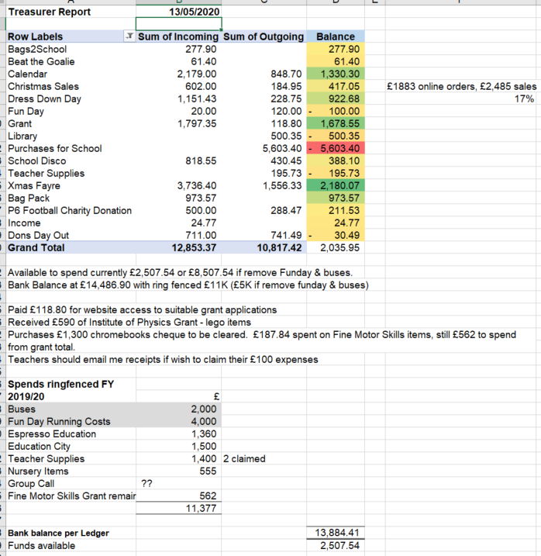

**Head Teacher’s Report**

Mrs Thomson gave an update on the hub at Westhill Primary School. Each cluster Head Teacher and Senior Management Team take it in turns to manage. It is mainly staffed by Pupil Support Assistants and staff from Aberdeenshire Council’s Kids Club. It is a primarily a childcare facility as opposed to a school. Children attending are given access to the same home working as all other children.

Home Learning – this continues to be developed and any feedback is welcome. Mrs Thomson and Miss Anderson appreciate the engagement from families in these unprecedented circumstances and wish to thank all parents for their support.

**Issues Raised via Class Reps**

* Videos from Teachers – Mrs Thomson and Miss Anderson explained that all methods of communication will be looked at going forward but many platforms have security issues and also many teachers are looking after their own children as well as working.

**Grants**

Since the last meeting, the following grants have been applied for:

£500 from Persimmon Homes for netball & other sports equipment

£1,000 from NFU Mutual for graphic novels

£4,900 from the Bank of Scotland for rainbow room equipment

Up to £2,500 from Aldi for sports equipment

£1,000 from the Miss A M Pilkington Charitable Trust for Prim-Ed boxes across all year groups

£250 from Warburtons for money to be used by the pupil health group

Additionally, Mrs Thomson has applied for £400 from the London Mathematical Society to help provide CPD training for teachers.

No grants have been awarded in this period and one grant application was unsuccessful (NFU Mutual).

Many grant decisions and application deadlines are being deferred due to the current Covid-19 situation.  There is also a move towards prioritising support for organisations dealing with hardship due to Covid-19.

If anyone knows of any grant schemes through their work, please forward details to Fiona FitzGerald who will be happy to work on a grant application with you.

**Fundraising**

* On hold until schools reopen
* It was discussed and acknowledged that there are a number of families being affected financially due to furlough, salary cuts and redundancy. There is acknowledgement that this is not an advisable time to be fundraising but that focus should be on supporting our local school community.

**Requests for Funding**

* Education City Subscription £1050 – approved
* Primary 7 Barcaple Trip Refunds, £70 per child

Raised at the meeting, the office bearers took the question away for consideration. Payment was made by parents with a non refundable deposit of £70. School have asked Barcaple to waive this which is not feasible. Barcaple have offered to carry the amount over to the next booking. Miss Anderson asked Parent Council if they would subsidise this amount (circa £4k) until the current P6 parents pay their deposits for next year’s trip.

Giving this consideration there are 3 key points as to why this was declined;

1. It does not meet our constitution of benefiting the majority of the children in school
2. There would be a significant risk of Barcaple falling into receivership and the money not being repaid, circa £4k.
3. We would not be able to justify this loss of funds to the wider parent forum.

**AOCB**

None

**Dates of Next Parent Council Meetings**

To be confirmed.

**Table of Actions**

|  |  |  |  |  |
| --- | --- | --- | --- | --- |
| Ref No | Date Raised | Action | Owner | Status |
| 1019-04 | 04/10/2019 | Contact P&J re new outside equipment | Miss Anderson – Corporate Communications Officer | In progress |
| 1119-01 | 12/11/2019 | Wording of Behaviour Policy | Mrs Thomson | In progress |
| 1119-03 | 12/11/2019 | Contact Respect Me for information on training courses. Update – course available 9th September. | Christina Daniel | In progress |
| 1119-11 | 12/11/2019 | Purchase candy floss machine | Lauren | In progresss |
| 1219-04 | 10/12/2019 | Afternoon Tea – interest to be gauged | Class Reps | In progress |
| 1219-05 | 10/12/2019 | First Aid training – Pam to arrange a date | Pam | In progress |
| 0320-03 | 10/03/2020 | Contact TAQA for donations of reception furniture | Fiona | In progress |
| 0320-02 | 10/03/2020 | Cost of one off deep clean | Mrs Thomson | In progress |
| 0320-05 | 10/03/2020 | Contact a clothing recycling bin company to visit our site and identify a suitable location. | Mrs Thomson | In progress |