**ELRICK PRIMARY SCHOOL PARENT COUNCIL MINUTES**

**Friday 24th January 2020, 1.30 pm**

Location: Elrick Primary School

Attendees: Claire Taylor (Chair), Fiona FitzGerald (Vice Chair), Lauren Wade (Treasurer), Monique Blair (Secretary), Christina Daniel (P1AC), Alessandra Savassi (P6C), Miss Jenny Anderson (Acting Head Teacher), Mrs Margaret Rule (Acting Depute Head), Cllr Ron McKail, Cllr Alistair McKelvie

Apologies: Jackeline Rodrigues, Shalaka Samant, Santana Kidd, Louise Milne, Melody Kuo, Nara Morrison, Roslyn Chilton, Lesley Davie, Cllr Iris Walker

**Approval of December Meeting Minutes**

The minutes were agreed to be accurate.

**Review of Actions from October Meeting**

* 0618-04 The lorry that transports the council road sweeper has been out of action for some time. Claire and Cllr Walker have both been continuing to push for updates and a replacement transport has now been sourced. The playground will be swept w/c 27/01/20. The cost is £150 to £200. The school is not being asked to pay on this occasion but it is likely any future requests will have to be funded by the school or PC. Cllr McKelvie also commented on the amount of fallen leaves which are unsightly and slippery. Miss Anderson explained the janitor does what he can to keep the paths clear but it is too big a job for one person.
* 0918-02 Bruce contacted AFC Community Trust but no response received. Action closed.
* 1019-04 Contact P&J re new outside equipment. Miss Anderson has contacted Council Corporate comms and they will be taking forward.

**Treasurer’s Report**

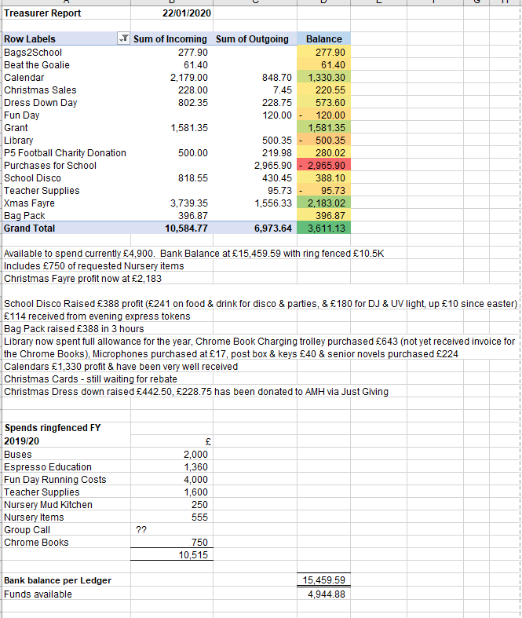

**Acting Head Teacher’s Report (Miss Anderson)**

**Issues Raised via Class Reps**

Walking Line

Queries have been raised by some parents about this. Mrs Rule explained the way it works.There is focus just now where all children are asked to stay quiet when walking between class areas in our open plan school. Anyone in P4 to P7 chatting and distracting over the week is not allowed an *extra* 10 minute break outside on Friday. Those children meet up together, inside usually with Miss Anderson and sometimes Mrs Rule, they take a light hearted walk through, the mainly empty school and have a general chat about why they are there. Staff would only feedback to parents if there were serious and repeat incidents. In the staffs opinion this is working quite well and they find that a child who may have walked the line once, does not do it again, having learnt their lesson.

**Fundraising**

* Christmas Disco Feedback
  + It was agreed to improve the sign out procedure at the end of the night.
* Tesco Bag Pack 2 February
  + We are still very short of volunteers and may have to consider cancelling some of the slots.
* Movie Night/Disco
  + Agreed to hold an Easter Disco. Wednesday 25th March. DJ to be booked asap.
* Dress Down Days
  + Wednesday 12th February. Theme of “Dress to Impress”. Suggested donation of £1.
* Dons Day Out
  + Letters will be sent home shortly.
* Bag2School – 3 March 2020
* Fun Day Planning
  + Agreed that separate meetings will be required for this. A letter for local businesses requesting raffle prizes to be drafted.

**Requests for Funding**

* Additional Support for Learning Requests - approved
  + Clicker Connect Symbolstix – 5 licences @ £59.99 each (£299.95)
  + Nessy – 25 licences @ £8 each (£200)
  + 30 sets of Headphones @ £12 each (£360)
* Recorders - £170 – approved
* Nursery Equipment – Mrs Rule to confirm whether funding is available for this from the extended hours funding (post meeting note: funding should be available)
* Set of 6 two way radios – these are required as the move to Skype has resulted in the school’s internal phone system being removed. Approved to a maximum cost of £500. Mrs Rule to find out which ones Crombie have.
* Post Box for office staff – Mrs Rule to clarify if the existing external post box is suitable

**AOCB**

**Dates of Next Parent Council Meetings**

Tuesday 10th March at 6.00 pm

Friday 1st May at 1.30 pm

**Table of Actions**

|  |  |  |  |  |
| --- | --- | --- | --- | --- |
| Ref No | Date Raised | Action | Owner | Status |
| 0618-04 | 14/06/2018 | Playground – condition of surface to be discussed with BSO and council roadsweeper to be requested. Awaiting a quote | Miss Anderson | In progress |
| ~~0918-02~~ | ~~19/09/2018~~ | ~~Get in touch with AFC community trust regarding fundraising~~ | ~~Bruce~~ | ~~Closed~~ |
| 1019-04 | 04/10/2019 | Contact P&J re new outside equipment | Miss Anderson – Corporate Communications Officer | In progress |
| 1119-01 | 12/11/2019 | Wording of Behaviour Policy | Mrs Thomson | In progress |
| 1119-03 | 12/11/2019 | Contact Respect Me for information on training courses | Christina Daniel | In progress |
| ~~1119-06~~ | ~~12/11/2019~~ | ~~Claire to email local councillors with playground/building concerns~~ | ~~Claire~~ | ~~Closed~~ |
| ~~1119-10~~ | ~~12/11/2019~~ | ~~Ideas for projects requiring grant funding~~ | ~~Miss Anderson~~ | ~~Closed~~ |
| 1119-11 | 12/11/2019 | Purchase candy floss machine | Lauren | In progresss |
| 1219-01 | 10/12/2019 | Parking Campaign – Health Group and community police | Miss Anderson | In progress |
| ~~1219-02~~ | ~~10/12/2019~~ | ~~Toy Appeal – Mrs Neave to review donations~~ | ~~Mrs Neave~~ | ~~Closed~~ |
| ~~1219-03~~ | ~~10/12/2019~~ | ~~Bag2School – Next dates to be booked~~ | ~~Claire~~ | ~~Closed~~ |
| 1219-04 | 10/12/2019 | Afternoon Tea – interest to be gauged | Class Reps | In progress |
| 1219-05 | 10/12/2019 | First Aid training – Pam to arrange a date | Pam | In progress |
| 0120-02 | 24/01/2020 | Easter Disco – DJ to be booked. Claire to contact Jackeline. | Claire/Jackeline | In progress |
| 0120-02 | 24/01/2020 | Fun Day – raffle prize letter to be drafted | ? | In progress |