ELRICK PRIMARY SCHOOL PARENT COUNCIL MINUTES
Tuesday 10th December 2019, 6.00 pm

Location: Elrick Primary School

Attendees: Claire Taylor (Chair), Fiona FitzGerald (Vice Chair), Lauren Wade (Treasurer), Monique Blair (Secretary), Shalaka Samant, Christina Daniel (P1AC), Lynn Glover (P1C), Alessandra Savassi (P6C), Jackeline Rodrigues (P3E), Pam Cheyne (P1AC), Miss Jenny Anderson (Acting Head Teacher), Mrs Margaret Rule (Acting Depute Head), Mrs Carly Neave (Acting Principal Teacher)

Apologies: Cllr Ron McKail, Bruce Bain, Lesley Currier, Lesley Davie, Louise Simpson, Louise Milne, Roslyn Chilton, Nara Morrison, Santana Kidd,

Approval of November Meeting Minutes

The minutes were agreed to be accurate.

Review of Actions from November Meeting

- 0618-04 Miss Anderson has spoken to the BSO and a quote to sweep the playground has been requested
- 1019-04 Contact P&J re new outside equipment. Miss Anderson to follow up with Council Corporate comms to arrange opening event with Director of Education etc. Still in progress
- 1119-01 Behaviour Policy – Local Authority is also looking the wording used. Miss Anderson to continue to work with staff on identifying and dealing with problem behaviours.
- 1119-02 Two confirmed cases of bullying in the last 2 years – both racially motivated. Alleged incidents are not recorded.
- 1119-06 Claire has emailed the local councillors about the condition of the school and the playgroud. She will chase up a response.

Treasurer’s Report
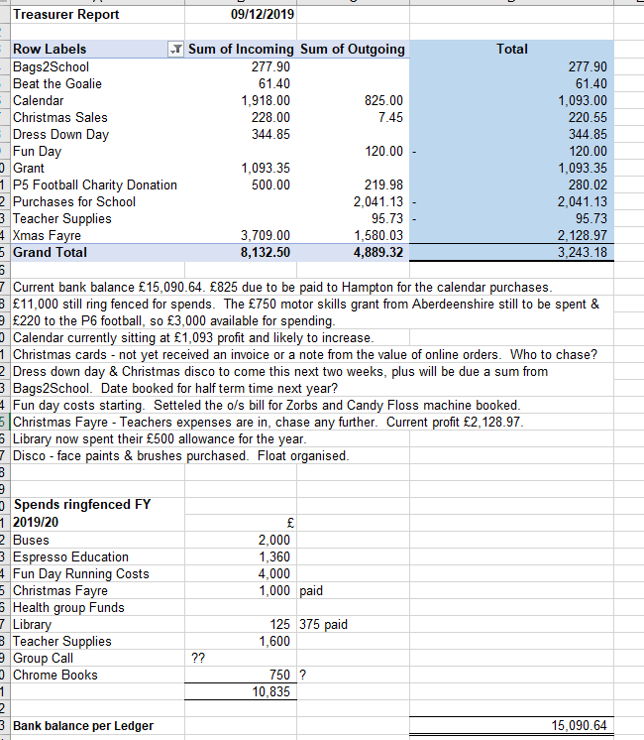

Acting Head Teacher’s Report (Miss Anderson)

Purpose of the Report
The purpose of the report is to update the Parent Forum on key areas at Elrick School. This will include staffing, trips and visitors, school improvements, reporting to parent opportunities for families as well as any other relevant information.
Trips and Visitors
- The last of our trips to Duthie Park took place with P1/2N and P3E going together. The children worked with the ranger, took part in orienteering activities and toured the Winter Gardens.
- A very successful family ceilidh was organised and run by P2/3Y and P3CS. Thanks to those who came along and enjoyed the afternoon and for their donations to the school in Rwanda – the staff and children’s hard work definitely paid off!
- P6 had a visit from the community link police officers regarding keeping safe when out and about in the local area.
- P6 pupils have taken part in curling taster sessions at Curl Aberdeen. This is funded by Active Schools.
- P7RD went to meet William - the boy who harnessed the wind at the International School.
- Both P7 classes went to the Music Hall to listen to talks about career options regarding Oceans.
- Yesterday P5 did some successful singing at the Westhill Shopping Centre, raising almost £280.
Staffing
- You will be aware we have a preferred candidate for the Head Teacher post – Mrs Fiona Thomson. Her starting date is to be confirmed soon. Thanks to those who took part in the recruitment process.
- PSA update: Mrs Linda Paterson started with us today, she works on a Tuesday and Friday.
- Mrs Robinson has returned from maternity leave and works as DHT on a Thursday and Friday.
- We are delighted to let you know that Miss Darlington had a baby girl, Mirrhyn on 26th November.
- Mrs Edwards will be full time in P3E from tomorrow. We thank Mrs Andrea Robertson for all her hard work over the past 5 weeks with the class.
- We welcomed our new Early Years Lead Practitioner, Mrs Nicola McKinlay, who started on Monday 9th December.
- We have a preferred candidate for early years practitioner maternity cover for Mrs Shimwell, 3 days, in our nursery. We will share more information about this once pre-employment checks are complete.
- An advert for Early Years Senior Practitioner went live but there were no applicants at this point. The post will be re-advertised in the new year.

School Improvements
Since the last Parent Council meeting, the school community has been working on the following improvements:
- Inservice training for staff took place on Monday 18th and Tuesday 19th November. On the Monday Mrs Rule led a session on streamlining of spelling programmes across the school, working groups continued to move forward the improvement plan and Miss Montgomery led on Making Thinking Visible strategies.
- Nursery staff and children have started their regular small group visits to Arnhall Moss on a Friday.
- We had our network upgrade – some desktops were replaced by laptops, all machines now using Windows 10. Many thanks again for the extra money put towards Chromebooks.
- P4F have returned to their classroom.
- Nursery building works are complete on the inside and the outdoor area will be completed by the end of term.
- Mrs Neave and Mrs Scott delivered a super collegiate session to staff about the work of Froebel – play-based learning and how this is being delivered at Early Level.]
- Mrs Neave supported staff with a refresher session about the use of Twitter this evening!
- Reminder: Our draft Standard and Quality report, plus school improvement plan was shared with parents through the school website.

Reporting to Parent Opportunities
As part of being a parent at Elrick School we try to provide a range of opportunities for you to find out about your child’s learning both as an individual and as part of their class. Recently, we have:
- Performances for parents were shared through the family ceilidh mentioned earlier and the P5 singing. P6 and Nursery children will be giving a Christmas performance in the last week of term.
- We continue to profile learning through your child’s SEESAW page. Please check you have access to this and contact your child’s teacher if you need the code to get on their profile.

Please remember that if you do want to discuss anything about your child, please contact the school.

Parking Campaign
Problems continue with speeding, dangerous manoeuvering and inconsiderate/illegal parking. Despite reminders from the school, some parents are also continuing to use the staff car park for drop off and pick up. Other schools in the area have had speeding/parking education campaigns run by pupils with the help of community police officers. Miss Anderson suggested the Health Group could be involved with the support of Westhill’s community police officer. Miss Anderson to take forward.
Toy Appeal
The appeal has been very successful and a large number of toys and play kitchens have been donated. Special thanks to Westhill Service Station for agreeing to be a drop off point. Mrs Neave to review donations received so far to assess how much longer the appeal should run.
Issues Raised via Class Reps
Communication Between School & Parents – Some class reps are continually being asked for information by parents. Miss Anderson advised that all upcoming dates and any other information from both the school and parent council are in the weekly “Dates for Diaries” email on a Friday and parents should be referred to this. Anyone who is not receiving this e-mail should contact the school office.
Fundraising
Christmas Disco – The discos will be held on 18th December. The entry fee is £3 and will include a drink and snack. Volunteers are still required, particularly for the last disco which also needs a first aider. Christina to give Claire an update and Claire will do another facebook post asking for help.
M&S Bag Pack – agreed to go ahead from 8am to 11am if there are enough volunteers, Claire to do a facebook post asking for help.
Bag2School – Claire to book dates for late January/early February.
Afternoon Tea Party on a Saturday. Holiday Inn charges £15pp which includes a drink on arrival followed by afternoon tea. We would provide our own entertainment such as bingo to raise more funds. Class reps to gauge interest in their classes.
Requests for Funding
Novels for Senior Pupils - £250 approved.
Class Christmas Party snack and drinks – approved. Shalaka and Christina to buy. School to provide numbers in each class along with any allergies.
Security Box £30 – large locked box for the reception area to allow parents and pupils to securely leave any items/order & money for parent council. This will greatly assist the office staff. Approved.
Mud Kitchen for Nursery – funding is available as part of the Aviva Grant. School to order.

AOCB

Staff are continuing to look at projects that would be suitable for grant applications. One suggestion is a locked cupboard to store and the chrome books and also allows them to be on charge. Miss Anderson to send details and cost of a suitable model to Bruce. Mrs Rule offered to help with the wording of any future applications if required.

First Aid Training – Pam has taken part in CPR and external defibrillator training run by the RNLI and Westhill & Kingswells First Responders. They are offering training free of charge in the school hall to parents/carers/staff. This can be in the evening and the only requirement is a minimum number of 5. There is also extended training available and anyone who completes this can then train others. Pam to contact them to arrange a date.

Dates of Next Parent Council Meetings

Friday 24th January at 1.30 pm
Tuesday 10th March at 6.00 pm
Friday 1st May at 1.30 pm

Table of Actions

Ref No | Date Raised | Action | Owner | Status
0618-04 | 14/06/2018 | Playground – condition of surface to be discussed with BSO and council roadsweeper to be requested. Awaiting a quote | Miss Anderson | In progress
0918-02 | 19/09/2018 | Get in touch with AFC community trust regarding fundraising | Bruce | In progress
1019-01 | 04/10/2019 | Summary of PC remit, role of class reps and FAQ | Claire/Fiona | Closed
1019-04 | 04/10/2019 | M&S Bag Pack – Christmas Eve booked | Claire | Closed
1019-04 | 04/10/2019 | Contact P&J re new outside equipment | Miss Anderson – Corporate Communications Officer | In progress
1119-01 | 12/11/2019 | Wording of Behaviour Policy | Miss Anderson | In progress
1119-02 | 12/11/2019 | Confirm number of recorded bullying incidents and number of bullying allegations – each academic year for the last 3 years | Miss Anderson | Closed
1119-03 | 12/11/2019 | Contact Respect Me for information on training courses | Christina Daniel | In progress
1119-04 | 12/11/2019 | Arrange another GLOW/SEESAW drop in session. Parents can raise specific concerns direct and a future drop in will be held if necessary | Mrs Rule | Closed
1119-05 | 12/11/2019 | Parents be reminded about using SEESAW | Miss Anderson | Closed
1119-06 | 12/11/2019 | Claire to email local councillors with playground/building concerns | Claire | In progress
1119-07 | 12/11/2019 | Email to be sent advising parents that 50% of Christmas dress down day funds will go to Mental Health Aberdeen in Liam Smith’s memory | Claire | Closed
1119-08 | 12/11/2019 | Book Disco UV lights | Jackeline | Closed
1119-09 | 12/11/2019 | Claire to book Bag2School Date | Claire | Closed
1119-10 | 12/11/2019 | Ideas for projects requiring grant funding | Miss Anderson | In progress
1119-11 | 12/11/2019 | Purchase candy floss machine | Lauren | In progresss
1219-01 | 10/12/2019 | Parking Campaign – Health Group and community police | Miss Anderson | In progress
1219-02 | 10/12/2019 | Toy Appeal – Mrs Neave to review donations | Mrs Neave | In progress
1219-03 | 10/12/2019 | Bag2School – Next dates to be booked | Claire | In progress
1219-04 | 10/12/2019 | Afternoon Tea – interest to be gauged | Class Reps | In progress
1219-05 | 10/12/2019 | First Aid training – Pam to arrange a date | Pam | In progress

