P2/3 Newsletter Term 3

Happy New Year to you all. The holiday seems like a long time ago and we feel we are well into the term. Many thanks for your kind gifts at Christmas.
Homework
A copy is in your child’s homework jotter. Discussion and submission of homework will be on a Monday. Homework jotters will be given out on a Wednesday.
Library
Your child will have the opportunity to choose a library book each week on a Tuesday. Please spend time with your child reading their book. Books are expected to be returned to the library the following week; however you can choose to keep longer books for an additional week. The children will only be able to choose a new book to take home if they have returned the previous one.

Timetable for Term 1

Monday | Tuesday | Wednesday | Thursday | Friday
P.E.  With Mrs MacLelland | Library  Art with Mrs Matthew | Assembly  PE with Mrs MacLelland | Activity Time | Fruity Friday

Dates for your diary!
Date | Event
Wednesday 12th February | Rwanda Day – P2/3 and P3CS are organising a fundraising event for a school in Rwanda for their enterprise project.
Thursday 13th – Wednesday 19th February | Mid-term holiday and In-service days
Friday 3rd April | Last day of term
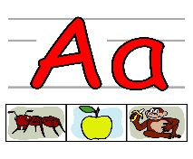

Literacy
Phonics/spelling
We will practise the spelling/phonics words, using strategies such as stretching the words, counting the sounds and using known spelling rules.
Writing
The children will be developing their writing skills this term through a focus on imaginative writing and poetry. We will continue to focus on using capital letters and full stops correctly. Some children will also be encouraged to use a range of conjunctions, interesting vocabulary and adjectives. Forming letters correctly and making sure they are the correct size will also be a focus as well as joining letters for some.

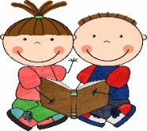
Reading
Children will continue to receive 2 reading books each week. One of the books will be sent home unseen and may be one that they have read before to help with fluency. Please encourage your child to read every day. If your child needs support with fluency in reading, then reading it three or four times will help: read it to parents, siblings, a pet, or toy. Reading books/ information from the home, the library and wider environment will help vocabulary development, understanding and fluency.
Some Primary 3 will receive two reading books but this will depend on the length of the books.

Numeracy and Mathematics
This term we will focussing on multiplication and linking with division, number pattern and symmentry . We will revise our knowledge of making arrays and develop an understanding of what the division sign means. Some of the children will be ready to start learning their times table/division facts. In P3 this will be extended to developing strategies for working out the 4x and 8x table facts and linking to division. Knowledge of times tables will greatly help this process. We will also continue to develop our mental agility.

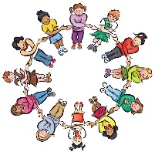
Health and Well Being
We will talk about how adverts can influence our choices. We will also look at healthy eating.

Contexts for Learning
Our topic this term will be learning about where our food comes from. We will also learn about our local landscape.
Ideas to Help at Home

- Encourage your child to read books other than those brought home as reading books. To read on a regular basis and to revisit books for fluency and understanding. Also try to include some non-fiction books, newspapers and poetry.
- Have a go at making symmetrical patterns. This could be done using Lego or other materials.
- Keep practising the number bonds within 10 and within 20.
- Talk to your child about the adverts they see online and on the TV. Discuss why they are appealing.
- Practise letter formation/ joining letters.

If there is anything that you wish to discuss further, then please do not hesitate to ask.
Thank you for your help and support.

Mrs Young

