**ELRICK PRIMARY SCHOOL PARENT COUNCIL MINUTES**

**Friday 4th October 2019, 1.30 pm**

Location: Elrick Primary School

Attendees: Claire Taylor (Chair), Lauren Wade (Treasurer), Monique Blair (Secretary), Christina Daniel (P1AC), Bruce Bain, Lynn Glover (P1C), Donna Morrison (P5B), Louise Milne (P4F), Alessandra Savassi (P6C), Lesley Davie (P3CS & P4SB), Roslyn Chilton (P3CS), Aimee Douglas Smith, Mrs Andrea Drummond (Head Teacher), Miss Jenny Anderson (Depute Head), Cllr Alistair McKelvie

Apologies: Fiona Fitzgerald (Vice Chair), Jackeline Rodrigues, Shalaka Samant, Pam Cheyne, Chrissie Simpson, Cllr Iris Walker, Cllr Ron McKail

**Approval of June & September AGM PC meeting minutes**

The minutes of both meetings were agreed to be accurate.

**Review of Actions from June & September PC meetings**

* 0618-02 The school has replaced all of the trophies that were either damaged or had no space left for more names.
* 0618-04 Mrs Drummond to contact Mr Jim Robertson from Aberdeenshire Council’s landscaping team to see if anything can be done to help and copy in Cllr McKelvie.
* 0918- 01 The school has replaced all of the trophies that were either damaged or had no space left for more names.
* 0918-02 Fiona and Alessandra had previously contacted AFC Community Trust but not received a response. Alessandra and Bruce to chase up.

**Treasurer’s Report**

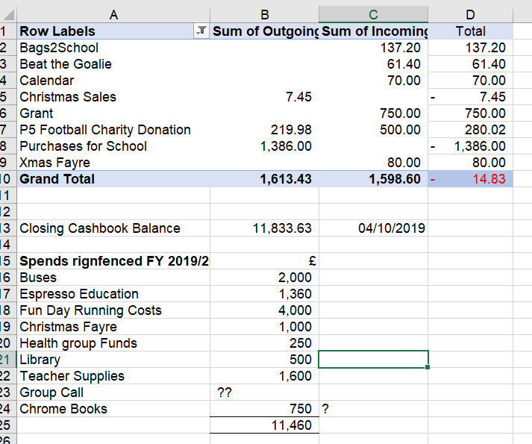

**Head Teacher’s Report (Mrs. Drummond)**

Purpose of the Report

The purpose of the report is to update the Parent Forum on key areas at Elrick School. This will include staffing, trips and visitors, school improvements, reporting to parent opportunities for families as well as any other relevant information.

Firstly, the staff of Elrick School would like to thank the Parent Council for their very kind gift you left in the staffroom. Coming towards the end of term when staff have just finished reports, planning next term was much appreciated.

Trips and Visitors

* Our new playground equipment and outdoor classrooms has been installed and children are using the equipment regularly
* We ran sessions for P4 and P5 with a local drama provider to develop their drama skills further
* Primary 7 parents were invited to a meeting to discuss Barcaple
* Nursery parents were offered a chance to attend a nursery curriculum meeting
* Tempest photography were in school to take whole class photos. They will return later in the year for P1 and P7 individual photos.
* Greg Botrill, author and expert in play, was in school to work with our early years staff to build on the active play opportunities available as part of their learning

Staffing

* We have new PSAs – 2 sharing the permanent hours and 2 sharing temporary hours, with a current advert for 8hrs on My Job Scotland website.
* Mrs Rule has been appointed as acting depute head teacher to support the senior leadership team during the time when Miss Anderson is acting head teacher
* We are currently recruiting for an acting principal teacher as Mrs Rule was doing this role
* We are interviewing for lead practitioner, 3 days, in our nursery shortly and hope to share some news following this interviews

School Improvements

Since the last Parent Council meeting, the school community has been working on the following improvements:

* Our draft Standard and Quality report, plus school improvement plan was shared with parents through the school website. This will be an active document which should be updated with progress during the year. This will make it much clearer to parents the progress the school is making on a more frequent basis.
* Staff attended a session led by senior leaders in Aberdeenshire Council to support self-evaluation across the school. This is part of a project involving a trio of schools where we are partnered with Insch and Dunecht school. We started this process last year in a pilot phase and now are fully engaged in this opportunity.
* We had our annual quality assurance visit from the cluster business support officer to make sure our finances and processes were in order
* Staff working parties have already made good progress towards some of their agreed actions with updated grammar progressions available, more coherent phonics and spelling progressions being used from P1 upwards, our network files becoming more organised for the move to Office 365, purposeful and planned play opportunities further developed and linking clearly with A Curriculum for Excellence, a planning tool for 1+2 languages available for all staff and the investigation into the possible use of Duolingo for schools underway
* Nursery staff have met with the ranger from Arnhall Moss to look at suitable areas for the nursery to use on a regular basis
* Our attainment review took place with the quality improvement officer and we will now attend a cluster attainment review with Westhill cluster.

Reporting to Parent Opportunities

As part of being a parent at Elrick School we try to provide a range of opportunities for you to find out about your child’s learning both as an individual and as part of their class. Recently, we have:

* Set up SEESAW and requested annual permission from all parents. Parents who have given consent have been issued with their own unique code- please can you encourage parents to check they can log into SEESAW
* GLOW – teachers will be moving (or for some classes have moved) to sharing homework via Microsoft teams. Please ensure your child can log into GLOW. (P1 user names and passwords to follow)
* Interim reports will be issued to parents next week along with Parent Interview times. Please encourage parents to check school bags. Parent/teacher appointments will take place during the 2nd week back next term.

Please remember that if you do want to discuss anything about your child, please contact the school.

**Update on Recruitment for Head Teacher**

The post will be advertised shortly. In the meantime Miss Jenny Anderson will be Acting Head Teacher.

**Library Update**

There have been several new volunteers to help with the library. There will not be a full rota until after the October holidays due to PVG checks still being carried out.

There is not enough time to fit in a library slot for nursery so a box of books will be sent over on a termly basis.

A major update of books is required. Parent Council allocate £500 annually for the library. Input is requested from staff and pupils on what books/authors they would like. Any old books that are no longer required by the library will be sent to Book Aid.

The next book fair will be on Thursday 31st October. Helpers are required between 9.00 to 10.30 and 1.30 to 6.00.

**Communications – Role of Class Reps**

Claire and Fiona will put together a short summary of the remit of the Parent Council and the role of Class Reps along with some FAQs. This will be posted on the school’s internet page for reference.

**Issues Raised via Class Reps**

The playground surface is now approx. 30 years old and in a poor condition with loose stones and grit. The cost to resurface will be tens of thousands of pounds and the school and local authority do not have these funds available. In addition there is no access to the playground for heavy machinery. Mrs Drummond to email Mr Jim Robertson from Aberdeenshire Council’s landscaping services to see if there if any improvements can be made. Cllr McKelvie to be copied in.

Reasons for lining up in Clans instead of classes – there is a leaflet explaining the reasons and the school will publish it on their internet site.

**Fundraising**

Dress Down Days – there will be a festive dress down day on the same day as Christmas lunch day. Date TBC.

Christmas Fayre – The Christmas Fayre will be held on 2nd Nov 11.00 to 1.00 pm. Classes have been invited to make some Xmas products and external stall holders have already been invited. We will require parents to help on the day.

Christmas Disco – The discos will be held on 18th December. The entry fee is £3 and will include a drink and snack. The timings of the disco will be:

5.30 to 6.15 P1-P2

6.30 to 7.15 P3-P4

7.30 to 8.30 P5-P7

Dons Day Out – this is a great fundraiser for the school as AFC gives us 50% of our total ticket sales. Roslyn agreed to organise.

Christmas M&S bag pack – Shalaka to book.

**Requests for Funding**

Every year each class is allocated £100 for teachers to spend how they see fit. Total cost approx. £1800. This was approved.

A request was made for a contribution towards buses for school trips to reduce the cost for parents. £100 per class – total £1800. This was approved.

**AOCB**

Grants – Bruce asked for any local business contacts for companies that might have community funding available.

Aviva & Aberdeen Airport Grants – The new outdoor classrooms, play equipment and buddy benches have been installed. It was agreed we should contact the P&J to see if they would like to run a story.

**Dates of Parent Council meeting (Until Dec 2019)**

The dates for this year’s Parent Council meetings (until end of 2019) are as follows:

12th Nov @ 6.00 pm

10th Dec @ 6.00 pm

**Table of Actions (Carried forward from June PC meeting, to be discussed at the Oct PC meeting)**

|  |  |  |  |  |
| --- | --- | --- | --- | --- |
| Ref No | Date Raised | Action | Owner | Status |
| ~~0618-02~~ | ~~14/06/2018~~ | ~~Replacement of Trophies – contact locals business for sponsorship~~ | ~~Kay Grieve~~ | ~~Closed~~ |
| 0618-04 | 14/06/2018 | Playground – condition of surface to be discussed with BSO and council roadsweeper to be requested | Mrs Drummond | In progress |
| ~~0918- 01~~ | ~~19/09/2018~~ | ~~Replacement of trophies–Letter to be drafted to local company~~ | ~~Fiona~~ | ~~Closed~~ |
| 0918-02 | 19/09/2018 | Get in touch with AFC community trust regarding fundraising | Alessandra/Bruce | In progress |
| 1019-01 | 04/10/2019 | Summary of PC remit, role of class reps and FAQ | Claire/Fiona | In progress |
| 1019-02 | 04/10/2019 | Clan leaflet to be published on school website | Mrs Drummond | In progress |
| 1019-03 | 04/10/2019 | Dons Day Out – date to be set | Roslyn | In progress |
| 1019-04 | 04/10/2019 | M&S Bag Pack – Shalaka to book | Shalaka | In progress |
| 1019-04 | 04/10/2019 | Contact P&J re new outside equipment | Claire | In progress |