 |  | Pass It On… The FUNDAY issue
4th May 2017
Parent Forum Meetings  AGM 7th June 6.00pm  Sandwiches and refreshments will be provided |  | Fun Day is coming!!! – Saturday 20th May 12.30pm – 3.30pm  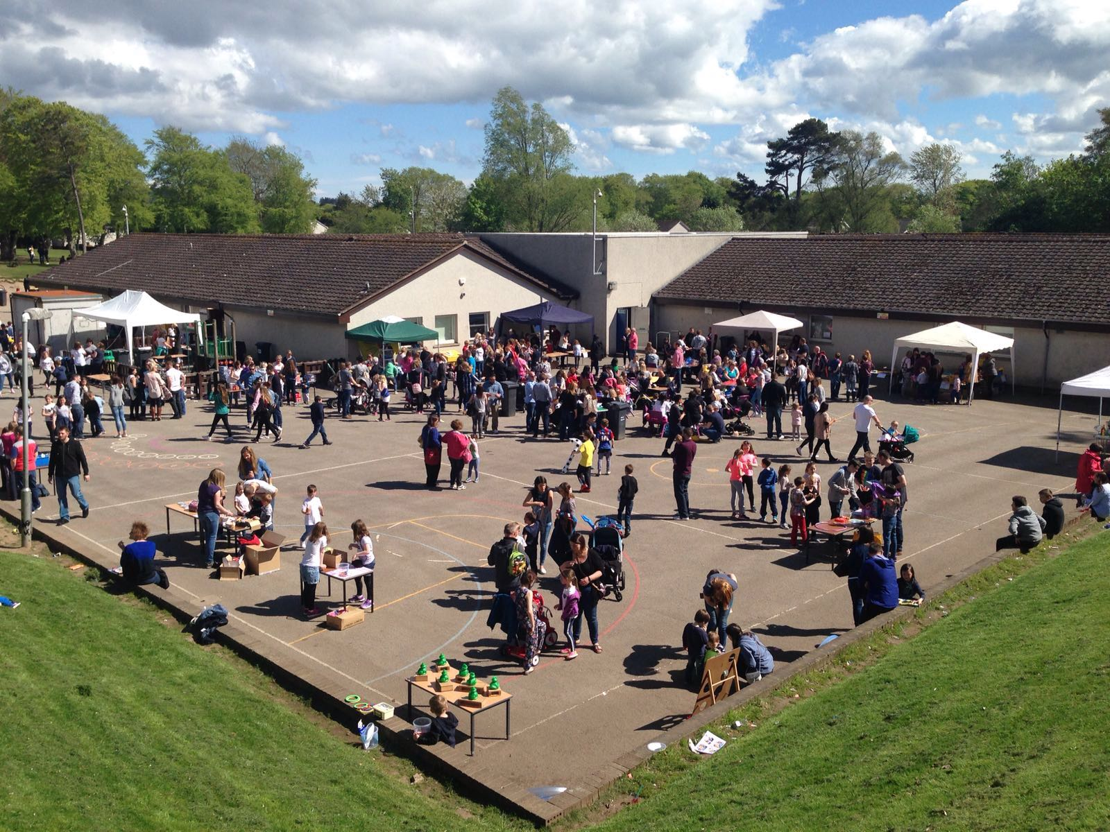  This is a special edition of Pass it On to let you know about all the exciting things we have planned for Funday this year!.........  We are looking to have another great event and keeping everything crossed for a nice sunny day. We have lots of activities for all the family to enjoy. On the field we will have a bouncy castle and beat the goalie. There will be tombolas, nail bars, face painting, tattoos, lucky dips, pocket money stalls and raffle (not forgetting a prize for the family that sells the most raffle tickets!).  New for this year* We have Jousting, a bring and buy teddy stall, plus the chance to give our Giant Monkey a home by guessing his date of birth. Hollywood Cars are providing Limousine rides so you can cruise round Westhill like a film star!  You won’t go hungry whilst you’re there! – There is a tuck shop, an amazing BBQ, candyfloss, sweet treats, home baking stalls and a licensed bar for the grown-ups, so come down early for lunch and make an afternoon of it!  Limo Rides – These bookings will be taken in person on a first come, first served basis on the week beginning 15th May – more details will follow next week.  There really is something for ALL the family, and it is certainly one of the most popular events in our school calendar. Read on to see how you can help…  Donations.  Every year we ask for your help with donations – these contribute greatly to the fun and financial success of the day.  All donations should be handed into school from the week beginning 15th May or on Fun day itself between 11am and Noon  Nursery and P1-P3  *Two wrapped items clearly marked ‘boy’ or ‘girl’ for the lucky dip (approximate value of £1 per item)  P4-P7  *A donation for the bottle tombola  All Years  *Home baking donations (please remember any home baking donations should not include fresh cream or raw eggs. If possible, please attach a label with a list of ingredients and should you wish to suggest a price for your donation, please do so) Donations for the chocolate tombola  *Unwanted books and DVDs in good condition.  *A cuddly toy you don’t mind giving up that’s in good condition  * Raffle prizes  HELP REQUIRED  Fun Day can only be a success with help from You, the parents. To enable the afternoon to run smoothly we need a great deal of help and we are looking for you to volunteer for an hour of your time on a stall. Please see the attached form for details and reply as soon as possible. Thank you!  