Primary 6LR Newsletter

**Term 2**

**Homework**

Homework will be uploaded to GLOW on a Friday and should be handed in the following Thursday. Please let Mrs Lloyd know if you are unable to access the homework, and hard copies of materials can be sent home.

**Reading**

This term, we will be using our group novels to further develop our reading skills, looking particularly at writer’s craft. We have just begun ‘Hitler’s Canary’ as our class novel, which ties into our new topic of World War II.

Every child should have an ERIC (Everybody Reading in Class) book in class every day. If your child does not have a book to enjoy, they can borrow one from the class library.

**Resources and Water Bottles**

Every day in school you need: a pencil, water bottle, waterproof jacket and gym kit (your gym kit should include outdoor and indoor shoes). As we are using Westdyke Leisure Centre this term, it is essential that indoor shoes are worn. You can keep a water bottle in class and have access to it during the school day.

**Numeracy and Mathematics**

This term, we will be working on developing our algebraic thinking. This will focus on exploring patterns and recognising the steps. We will look at function machines using the four operations and solving basic equations. With Mrs Reid, we will be learning about the properties of 2D and 3D shapes.

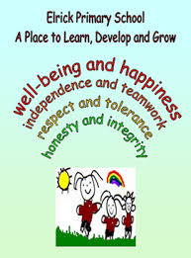

***The Elrick Rainbow***

**Timetable**

|  |  |
| --- | --- |
| Monday | * Science |
| Tuesday | * Library |
| Wednesday | * Assembly * P.E * French |
| Thursday | * P.E * Homework due |
| Friday | * Homework uploaded to GLOW |

Our class charter

As a class, we continue to abide by our class charter:

· To work together and support each other

· To not interrupt each other’s learning

· To respect each other

· To use the school property properly and respect it

· To have fun and smile while learning

Our daily CLIC sessions continue to improve our mental agility. This term we will focus on negative numbers, multiplying decimals, and enhancing our recall and comprehension of the times tables.

**Literacy**

In writing, we continue to up-level our writing using more sophisticated vocabulary. We are also working to ensure basic punctuation such as capital letters and full stops is always in place. In our report writing and imaginative writing, we are focusing on incorporating language techniques, such as similes and metaphors, to make our writing more interesting.

We will continue to develop our spelling phoneme knowledge to allow us greater independence in our writing, and encourage us to use a wider vocabulary.

**Health and Wellbeing and other Curricular Areas**

Our WWII focus is learning about key events during this time, and making comparisons with life now.

Unfortunately we no longer have class Mindfulness sessions with Mrs Fairley, but as it proved so popular and effective in managing our stress and maintaining focus, we continue to work on it as a class.

In P.E we develop our growth mindset through affirmations, a positive outlook as to our physical abilities, and examining the theory behind better performance.

This term in science, we are working with Mrs Skinner in learning about Light.

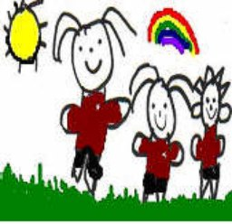

**How to help your child**

* Talk to your child about their learning.
* Continue to encourage your child to talk about the learning pit and what strategies they are using to get out of it.
* Encourage your child to read for pleasure, discussing new and interesting vocabulary.
* Discuss WWII with us. What links does your family have to the war? Are any of your friends and family able to share their experiences?

**Mrs Lloyd and Mrs Reid**