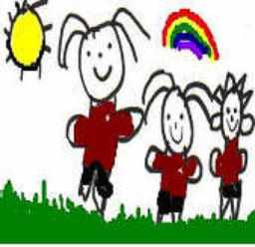
2017-2018
P3S Newsletter Term 1
A Warm welcome to Primary 3
I hope you had a lovely summer break and are ready for an exciting year ahead.
It is important that we work closely together communicating regularly about your child’s progress and success. The purpose of this newsletter is to let you know what your child will be learning over the next six weeks up to the October break. I have also included some other relevant information about this term. Please do not hesitate to get in touch should you have any questions.
Timetable
The children will have science, music and P.E this term. Names of the teachers who will be delivering these sessions are listed below. I will also take the children for a P.E. session each week to help deliver the 2 hours of recommended P.E. each week and where possible we will try to get out and do our daily mile. The children will be outside for P.E. as much as possible. Can you please ensure that they have suitable clothing such as joggers and a hoodie as well as shorts and a t-shirt and both indoor and outdoor gym shoes. This term the children will also be participating in a weekly class session of mindfulness.
Specialist Teachers

P.E. with Mr Adey
Science with Mrs Skinner
Music with Mrs O’Gallagher
Mindfulness with Donna Fairley
Mon | Tues | Wed | Thurs | Fri
Science | P.E.  Library | Mindfulness  Assembly | Music  Activity Time | P.E.

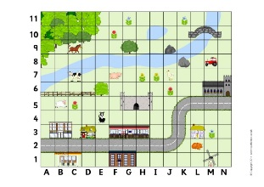
The children will also have the opportunity to visit the school library each week starting form the week beginning 18th September. Please help to encourage a love of books, stories and reading by sharing these books with your children at home.

Numeracy
We have started the new school year by looking at place value, sequential numbers and we will also do some consolidation on addition, subtraction and skip counting to help build on our times tables knowledge.
We will also be looking at mapping and co-ordinates which will link with our novel study, Fantastic Mr Fox.

Health and Wellbeing
As well as encouraging the children to be active, we will focus on settling in, looking at our class charter, how we move around the school respectfully with good manners and consideration for others. We will continue to embed the vision and aims of the Elrick Rainbow to promote a positive learning environment along with our mindfulness sessions. We will also focus on developing our co-operative skills in order for them to develop a variety of group roles.

Literacy/ Other Curricular Areas
Our topic this term will be a book study on Fantastic Mr Fox. As well as developing the children’s literacy skills in character, setting and imaginative writing the book study will allow us to incorporate other curricular areas. In science we will focus on sounds in our ever day lives. We will also explore our local environment and consider how we can care for it. In our R.M.E. we will learn about celebrations in Christianity and other World Religions.
Homework
Homework will be put on our Glow homework page on a Wednesday and any written work should be returned the following Monday. We will reset all Glow passwords to Primary 3. It will prompt you to change it to a more memorable password. Please record this on the inside cover of your child’s homework jotter as well as the return slip for our class records. There will also be a note of their Education City Password in the front of their homework jotters. The children will also continue to receive 2 reading books each week on a Tuesday and Thursday. This term we will look at decoding by using the text and illustrations to help us understand what we read. Please take the time to look at these books with your child.

I have put in a reminder about how to access the glow page, but should you have any questions please do not hesitate to get in touch.
Once logged in, click on the tab that says ‘School Site’. You will be able to click on the P3S class page from the School Site. Click on the homework tab to find it. If you have any questions regarding Glow or how to log on, please do not hesitate to ask.

Date for your Diary
- Parent Meetings - Thursday 5th, Tuesday 10th and Wednesday 11th October
- End of term 1 – Friday 13th October

Any other dates will be updated on our class page.
How to support your child
- Encourage your child to talk about their learning, what learning is happening at
school, how they like to learn.
- Talk to your child about their strengths and interests and how they are progressing.
- Look for opportunities at home to develop literacy and numeracy skills: Help your
child to plan a journey, talk about direction, practise number bonds and counting in
2s, 5s and 10s. In literacy talk about stories that you have read together, discuss
the key events, main characters and setting.

ERIC Time (Everyone Reading in Class)

- In ERIC time we encourage the children to read for enjoyment. Your child may wish to take a magazine, book, novel, comic, non-fiction etc. to keep in their tray for this time.

