P3 of P2/3 Newsletter
Term 4
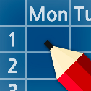 Timetable

Monday | Tuesday | Wednesday | Thursday | Friday
PE – come to school in your PE kit. | Library | Assembly  PE | Science  Activity time  Homework due in | Kodaly singing  Homework handed out

Homework will continue to be handed out on a Friday and should be handed in the following Thursday. Homework information will be posted on GLOW. Homework should be completed in pencil and should be dated.

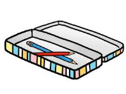Resources and Water Bottles

Every day in school you need: a pencil, water bottle, waterproof jacket, homework bag and gym kit. If it is raining bring your welly boots. You can keep a water bottle in class and have access to it during the school day.

Class Charter

Be Safe | Happy | Learn
- Look after our friends and school resources  - Go about the school safely | - Look after our friends  - Be kind to each other | - Always try your best  - Learn from your mistakes

Literacy

We will be working on sharing with each other our thoughts and opinions on what we have seen or heard. This will be supported through the making of notes under given headings. In reading we will continue develop taught strategies to decode unfamiliar vocabulary. While reading we will be investigating different aspects of grammar such as nouns, verbs, adjectives and connectives. We will be working on our narrative writing and look at writing to explain (e.g. What is the Learning Pit?). Spelling and phoneme development will continue as per last term.

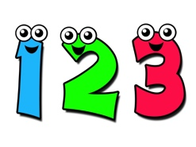Numeracy

There will be a focus on measurement and time this term. We will be developing accuracy when measuring and developing our precision in making estimations of area. In time, we will be looking at the relationships between different units of time and learn to use these units to measure the duration of events.
Through using our knowledge of division we will be exploring finding a fraction of an amount and looking at the connections between different fractions e.g. half and two quarters.

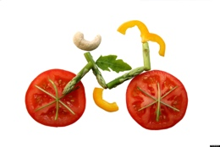Health and Well Being and Other Curricular Areas

We will be investigation food and its production within Scotland and how people use the land in our local environment.
In RME we will be looking at artefacts from different religions and finding out why they are important.

How to Help Your Child

- Encourage your child to talk about their learning, what learning is happening at school, how they like to learn, what strategies they use to get ‘out of the pit’
- Talk to your child about their strengths and interests and how they are progressing and what their next steps will be
- Chat to your child about your plan for the day. Match different times to different activities e.g. we will go to the shops at 11.15, the park at 3.30. Encourage your child to read the time as often as you can that day.
- Look for opportunities to talk about size, e.g. more than, less than, bigger, smaller. Measure your child’s height and keep a record together.
- Talk about how long everyday events take e.g. cooking times, journey times
- Play word games e.g. Scrabble, ‘What’s My Word’

Reading Strategies

Sound it out  c-a-t  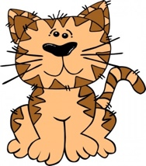 | Chunk it  ch – un – k | Say the first sound  Caterpillar
Look at the last sound  caterpillar | Blend sounds together  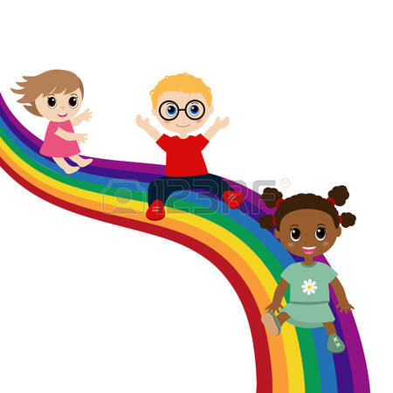 | Find clues in the picture  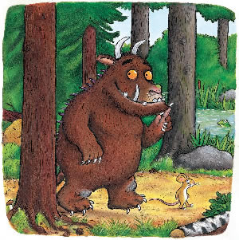
Skip ahead  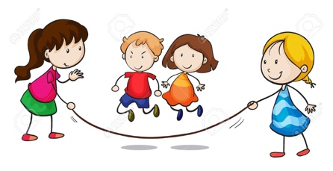 | Think what makes sense | Read it again
Use punctuation

