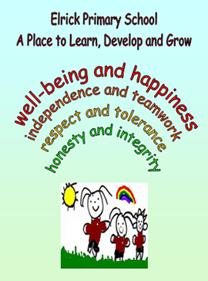
Primary 2B/C Newsletter
Welcome to term 4!

Timetable

Monday | - Paired reading
Tuesday | - P.E.
Wednesday | - Assembly  - Library
Thursday | - Music  - Activity time  - Homework due in
Friday | - P.E.  - Homework uploaded to GLOW

Homework
Homework will continue to be uploaded to GLOW on a Friday and should be handed in the following Thursday.

Reading
Reading books need to be in school every day.

Resources and Water Bottles
Every day in school you need: a pencil, water bottle, waterproof jacket and gym kit. You can keep a water bottle in class and have access to it during the school day.

Numeracy and Mathematics
This term, we will be continuing to develop our understanding of addition and subtraction by applying our number bonds to 10 and 20 in trickier sums; for example, if we know that 4+3=7, we also know 44+3=47 and so on. We are starting to look the relationship between multiplication and division by carrying out repeated edition e.g. 3x4= 3+3+3+3. Simple fractions, such as halves and quarters will also be introduced. Our daily CLIC sessions will improve our mental agility, including counting skills, doubling and halving and multiplication. In beyond number we will be developing our understanding of shape (2D shapes, 3D shapes and symmetry) and using bar charts and tables to find and organise information.

Literacy
Although we will continue to learn new some phonemes this term, for many of the weeks, the focus will be on applying our phoneme knowledge from terms 1-3. We will do this by exploring groups of phonemes which make the same sound, e.g. ai, ay and a-e, and looking at word families, e.g. play, say, clay. Also, we will practise the spelling of common and tricky words and apply these to our everyday writing.

This term, we will do paired reading with P6C. This will help us develop our own reading skills through listening to stories, reading along and reading aloud. It will also enable us to talk about books we have read and enjoyed.

In writing, we will be focusing on instructional and persuasive writing as well as some personal experience too. We will continue to work on consistent use of full stops and capital letters and improve the quality of our writing by using joining words (connectives) and using our extended vocabulary.

Health and Wellbeing and other Curricular Areas
Mid-term, we will celebrate World of Work week. In light of this, our topic will relate to enterprise and skills for learning life and work, such as data collection and information handling (which links to Maths). We will also hear from various speakers about career paths and choices.

Digital literacy continues to be a whole-school focus and as such, we will be learning more about coding and computing.

How to help your child
- Talk to your child about their learning.
- Continue to encourage your child to talk about the learning pit and what strategies they are using to get out of it.
- Help your child to develop their knowledge of shape by discussing with them the 3D shapes around them.
- Help your child use the vocabulary associated with position, e.g. above, next to.
- Enjoy reading together and talk about what type of book your child prefers, funny stories, adventure, information books?

