P2A Newsletter Term 2

We hope that you have enjoyed your October break – we are ready for a busy but fun term ahead!

A big welcome to Miss Alexander who has joined us and is now leading the teaching of the class. Mrs Adams will also continue to work with the class until she leaves to go on maternity leave on the 1st December.

It is important that we work together, communicating regularly about your child’s progress and successes. The purpose of this newsletter is to let you know what your child will be learning about during the following weeks leading up to Christmas. We have also included other relevant information, which may be useful over the course of the term.

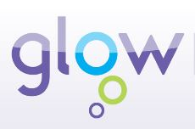

Glow

As you are aware, at Elrick, each class has a Glow page which will be used to share information, including homework.

To run successfully, Glow requires you to use Google Chrome as your web browser. To log in, type https://glow.rmunify.com in to your Google Chrome web browser and this will take you to the log in page.

Most children seem to be successfully accessing Glow using their username and new passwords. Please let us know if you are still experiencing difficulties logging on.

Once logged in, click on the tab that says ‘School Site’. You will be able to click on the P2A class page from the School Site. Click on the homework tab to find it. If you have any questions regarding Glow or how to log on, please do not hesitate to ask.

Homework
Homework will continue to be put on our Glow homework page on a Wednesday and any written work should be returned the following Monday.
There will also be a note of Education City Passwords in the front of their homework jotters.
The children will continue to receive 2 reading books each week. Please take the time to read with your child and encourage them to use the strategies that we are learning in class to help decode words, such as looking for the sounds that they know.

Paired Reading
Over the next 6 weeks the children will have the opportunity to select a book to take home to share with an adult as part of our Paired Reading initiative. Please return books inside their blue Paired Reading folder on a Monday (same return day as homework bags).

Please ensure that the children bring their reading book into school every day to allow us to use them in our literacy activities and also in case they are needed to pass to another class. We would advise that all children have a separate homework bag to carry their reading book, homework jotter and any letters that need to go home/be returned. This will prevent anything getting damaged inside a schoolbag.

Library

- Your child will continue to have the opportunity to choose a library book each week on a Tuesday. Please spend time with your child reading their book with them. Books are expected to be returned to the library the following week, unless you choose to keep it for an additional week. The children will only be able to choose a new book to take home if they have returned the previous one.

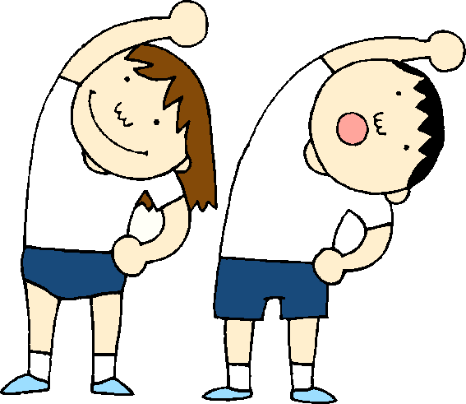
Timetable for Term 2

Monday | Tuesday | Wednesday | Thursday | Friday
Music with Mrs O’Gallagher  Paired Reading day  Homework handed in | Library | P.E. at Westdyke (come dressed in P.E. kit)  Assembly  Science with Mrs Bruce  New homework detailed on Glow | P.E with Mr Adey  Activity Time

Please ensure that the children have suitable clothing for P.E, including a pair of joggers/leggings and a hoodie or long sleeved top for cooler days.
** We are aware that some children do not have a separate pair of indoor gym shoes. Please ensure that your child has both an indoor and an outdoor pair of gymshoes/trainers in their kit bags.**

Dates for your diary!

Date | Event
Monday 13th and Tuesday 14th November | In-service days
Thursday 16th November | Children In Need - Dress down in spotty or bright coloured clothes for a donation
Friday 17th November | Class Photographs
Tuesday 12th December  9.45am P2A and P3S  Wednesday 13th December  2.15pm P2A and P3S | P2A/P3S Christmas Performance  **Letters to follow

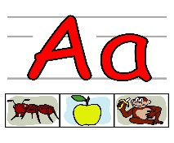

Literacy

Phonics
Each week the children will continue to be introduced to a new phonic sound. This will be done through an active approach with a variety of activities to help the children practise and consolidate their phonic knowledge.

Spelling
Each week the children will continue to be given 4 spelling words. The words are introduced to the children along with spelling strategies to help them to understand and retain the words. In class, we will practise the spelling words daily, through an active approach, and will discuss the strategies we have used to help us.

Writing
The children will be developing their writing skills this term through the genre of Recount. We will focus on both personal recount and the retelling of well-known stories. We will continue to encourage correct use of capital letters and full stops and for those who are ready, on using a wider selection of joining words.

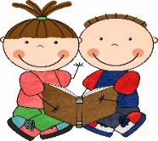
Reading The children will continue to receive 2 reading books home each week. This term we will be concentrating on breaking down the words in to parts, looking for the sounds we know to help us to read words. We will also be using a selection of non-fiction books to look for information as part of our context work on Ancient Egypt.

Numeracy and Mathematics

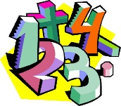
This term we will be focusing on addition and subtraction. We will be learning to develop our mental strategies to complete calculations, whilst also looking at the relationship between the two operations.

We will also continue to explore some apsects of Measure, investigating the concepts of area, weight and capacity. We will also explore 2D and 3D shape, identifying the names of shapes and describing their features.

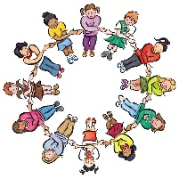

Health & Wellbeing and Other Curricular Areas

Health and Well Being
This term the children will be having Mindfulness sessions where they will learn a variety of methods to help with their focus, calming their minds and bodies ready for listening and learning. As a class, we will continue to explore aspects of Growth Mindset, looking at strategies to use when faced with a challenge or tricky situation.

Contexts for Learning
Our topic this term will be a historical focus, investigating Ancient Egypt. The children will compare aspects of people’s daily lives in the past with their own, through sub-topics such as pyramids, the importance of the River Nile, mummification and Egyptian dress.

Later on in the term, we will explore the celebration of Christmas, developing our understanding of Christian beliefs and traditions as they celebrate this time of year.

Science
In Science this term we will be investigating aspects of Electricity.

Ideas to Help at Home

- Revise previous sounds introduced last term, as well as making links with new sounds this term.
- Read together for enjoyment and encourage your child to talk about the different features of the book eg. author, illustrator, blurb, through library books and Paired Reading books.
- Help your child to look for links between number facts, eg. “I know that 7+3=10 so I can work out that 17+3=20 and 70+30=100”.
- Look for different 2D and 3D shapes in the environment and talk about their different features.

If there is anything that you wish to discuss further then please do not hesitate to ask.

Thank you for your continued help and support.

Mrs Adams, Miss Alexander and the pupils in P2A

