P2A Newsletter Term 1

A warm welcome to Primary 2A. I hope that you have had a lovely long summer break and are ready for an exciting year ahead as your child starts Primary Two.

It is important that we work together, communicating regularly about your child’s progress and successes. The purpose of this newsletter is to let you know what your child will be learning about during the next 6 weeks until the October break. I have also included other relevant information, which may be useful over the course of the term.

Glow

As you are aware, at Elrick, each class has a Glow page which will be used to share information, including homework.

To run successfully, Glow requires you to use Google Chrome as your web browser. To log in, type https://glow.rmunify.com in to your Google Chrome web browser and this will take you to the log in page.

We will reset all Glow passwords to Primary 2. It will prompt you to change it to a more memorable password. Please record this on the inside cover of your child’s homework jotter as well as the return slip for our class records.

Once logged in, click on the tab that says ‘School Site’. You will be able to click on the P2A class page from the School Site. Click on the homework tab to find it. If you have any questions regarding Glow or how to log on, please do not hesitate to ask.

Homework
Homework will be put on our Glow homework page on a Wednesday and any written work should be returned the following Monday.
There will also be a note of Education City Passwords in the front of their homework jotters.
The children will continue to receive 2 reading books each week. Please take the time to read with your child and encourage them to use the strategies that we are learning in class to help decode words, such as looking for the sounds that they know.

Please ensure that the children bring their reading book into school every day to allow us to use them in our literacy activities and also in case they are needed to pass to another class. We would advise that all children have a separate homework bag to carry their reading book, homework jotter and any letters that need to go home/be returned. This will prevent anything getting damaged inside a schoolbag.

Library

- Your child will have the opportunity to choose a library book each week on a Tuesday. Please spend time with your child reading their book with them. Books are expected to be returned to the library the following week, unless you choose to keep it for an additional week. The children will only be able to choose a new book to take home if they have returned the previous one.

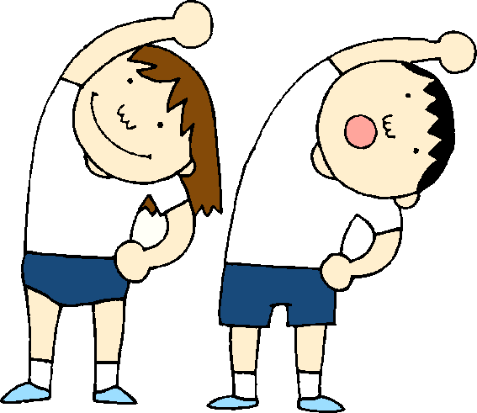
Timetable for Term 1

Monday | Tuesday | Wednesday | Thursday | Friday
Music with Mrs O’Gallagher  Homework handed in | Library | Assembly  Science with Mrs Bruce  New homework detailed on Glow | P.E with Mr Adey  Activity Time

This term, the children will be having their PE sessions outside as much as possible. Please ensure that the children have suitable clothing for this, including a pair of joggers/leggings and a hoodie or long sleeved top for cooler days. The children should also have both indoor and outdoor gymshoes/trainers.

Dates for your diary!

Date | Event
Thurs 5th Oct, Tues 10th Oct, Wed 11th Oct | Parent Interviews
Friday 13th Oct | Last day of Term
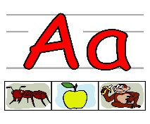

Literacy

Phonics
Each week the children will be introduced to a new phonic sound. This will be done through an active approach with a variety of activities to help the children practise and consolidate their phonic knowledge.

Spelling
Each week the children will be given 4 spelling words. The words are introduced to the children along with spelling strategies to help them to understand and retain the words. In class, we will practise the spelling words daily, through an active approach, and will discuss the strategies we have used to help us.

Writing
The children will be developing their writing skills this term through a Personal Recount focus and also through some functional letter writing. We will continue to focus on using capital letters and full stops correctly and for those who are ready, on using a wider selection of joining words.

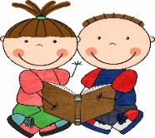
Reading The children will receive 2 reading books home each week. This term we will be concentrating on looking for the sounds we know to help us to read words.

Numeracy and Mathematics

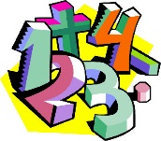
This term we will be learning about counting in sequences and using numbers to describe the order of items. We will be learning more about Place Value – looking at the value of digits within a number. We will also continue to develop our mental agility through using ‘counting on’ and ‘counting back’ to add and subtract numbers.

We will also be exploring different aspects of Measure – recording and comparing different measurements.
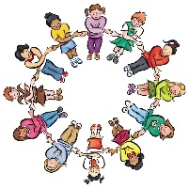

Health & Wellbeing and Other Curricular Areas

Health and Well Being
This term we will be developing our understanding of rights and responsibilities within the school setting. Thinking of Elrick’s Vision, Values and Aims, we are working co-operatively together to create a class charter which will be our guide to help us to achieve a happy and calm learning environment in our class.
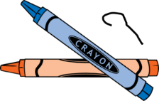

Contexts for Learning
Our first topic this term will be a literacy focus, based around the books “The Day the Crayons Quit” and “The Day the Crayons Came Home”. We will be exploring different features of the book and will use the story to support and compliment our learning in Literacy, Expressive Arts and Health and Wellbeing. We will explore all the colourful characters and will discuss the importance of resilience and looking for ways to find a solution to a problem. We will relate this to the Learning Pit.

Science
In Science this term we will be investigating aspects of Sound and Vibrations.

Ideas to Help at Home

- Encourage your child to look for sounds and spelling words in the environment
- Read together for enjoyment and encourage your child to talk about the different features of the book eg. author, illustrator, blurb.
- Look out for different numbers in the environment and discuss the value of different digits.
- Measure and compare the height and length of items around your home using non-standard units eg. hands, feet, crayons.

If there is anything that you wish to discuss further then please do not hesitate to ask.

Thank you for your continued help and support.

Mrs Adams and the pupils in P2A

