P1/2Y Newsletter Term 2

A warm welcome back after the holiday. The children are settling back into school life.

This purpose of this letter is to give you information about what the children will be involved in this term.

Timetable for Term 1

Monday | Tuesday | Wednesday | Thursday | Friday
Art with Mrs Donnelly | Library | Assembly | Music with Mrs O’Gallagher  Activity Time | 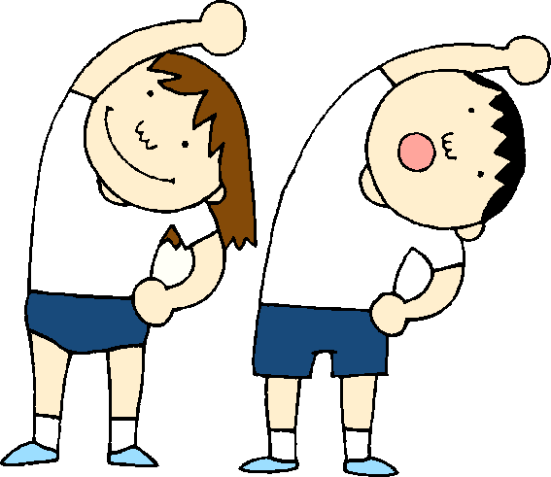  P.E with Mrs Donnelly

Dates for your diary

Date | Event
Thursday 16th November | Children in Need
Friday 17th November | Class Photographs
13th and 14th November | In-service days
Thursday 21st 11.00am | Christmas sing-a-long

Literacy
In P1 we will continue to learn new sounds and spelling words each week. These will be shared on Glow and in homework jotters.
In reading, we will be learning to use our knowledge of sounds to help us read by sounding out short words and by saying the first sound in a word, together with looking at the pictures.
In writing we will be learning to write some short words independently by using our knowledge of sounds and spelling words.
In P2 we will learn a new sound each week, with some weeks for consolidation. Words will be given on an individual basis for reading and spelling. The primary 2 will also work on building more complex words from known sounds and work on fluency in their reading. We will begin with some basic joins in handwriting. For the next six weeks the P2 will take books home for paired reading.
Ideas to Help at Home
• Regularly practise the words in your child’s new literacy box so your child can instantly recognise them
• (P1)Use the sounds in your child’s box to make words which they can read.
- Encourage your child when writing to form all letters correctly
• Read together for enjoyment regularly and talk about the characters, setting and plot
Numeracy and Mathematics

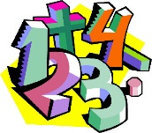
This term we are continuing to develop our sense of numbers by exploring and describing the order of numbers using the words before, between and after.
We will be developing our understanding of pattern by replicating, extending and creating our own patterns. In P2 this will include working out rules for number patterns.
We will be doing oral mental maths activities to develop our sense of numbers. In P2 concentrating on having instant recall of number bonds within ten and then twenty.
We will also be developing our understanding of the concepts of addition and subtraction and we will learn to demonstrate calculations in real-life contexts, this will be extended for P2.
Ideas to Help at Home
• Regularly ask your child to count forwards or backwards from different numbers.
- (P2) Practise quick recall on number bonds within 10 and then within 20 addition and subtraction
- • (P1)Help your child develop instant recognition of quantities to 10 e.g. show them dice patterns, fingers, playing cards and ask them to try and tell you how many without counting
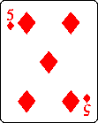

Health & Wellbeing and Other Curricular Areas

Our key contexts this term will be ‘Percy the Park Keeper’ and ‘Festivals’
We will be learning how to care for plants and animals in our school grounds
We will be finding out how to keep ourselves and others safe
We are learning about the importance of celebrations, festivals and customs in people’s lives
Ideas to Help at Home
• Look for signs of how we help animals in Autumn and Winter (e.g. bird feeders) and talk about why this is important
• Practise and model the Green Cross Code whilst you are out and about. Look for clothes that would be good for wearing when it is dark and talk about why this is important.

Primary 2 will be involved in a Christmas show with the other P2 classes – details will follow.

If there is anything that you wish to discuss further then please do not hesitate to ask.

Thank you for your help and support.

Mrs Young

