P1/2Y Newsletter Term 1

A warm welcome to Primary 1/2Y. I hope that you have had a great summer break and the children are enjoying the experience of being in school.

You will receive a letter each term to let you know what your children will be learning in the coming weeks. There will also be regular communication about your child’s progress and successes. I have also included other relevant information, which may be useful over the course of the term.

Glow

As you are aware, at Elrick, each class has a Glow page which will be used to share learning and information, including homework.

To run successfully, Glow requires you to use Google Chrome as your web browser. To log in, type https://glow.rmunify.com in to your Google Chrome web browser and this will take you to the log in page.

We will reset all Glow passwords to Primary 2. It will prompt you to change it to a more memorable password. Please record this on the inside cover of your child’s homework jotter as well as the return slip for our class records.

Once logged in, click on the tab that says ‘School Site’. You will be able to click on the P1/2Y class page from the School Site. Click on the homework tab to find it. If you have any questions regarding Glow or how to log on, please do not hesitate to ask.

Homework
Homework will be put on our Glow homework page on a Friday and any written work should be returned the following Wednesday.
There will also be a note of Education City Passwords in the front of their homework jotters in due course.
The children will continue to receive 2 reading books each week. Please take the time to read with your child and encourage them to use the strategies that we are learning in class to help decode words: such as looking for the sounds that they know, using picture clues, using the meaning of the sentence and first letter clues for P2 and sounds and sight words in P1.

Please ensure that the children bring their reading book into school every day to allow us to use them in our literacy activities and also in case they are needed to pass to another class. We would advise that all children have a separate homework bag to carry their reading book, homework jotter and any letters that need to go home/be returned. This will prevent anything getting damaged inside a schoolbag.

Library

- Your child will have the opportunity to choose a library book each week on a Tuesday. Please spend time with your child reading their book with them. Books are expected to be returned to the library the following week, unless you choose to keep it for an additional week. The children will only be able to choose a new book to take home if they have returned the previous one.

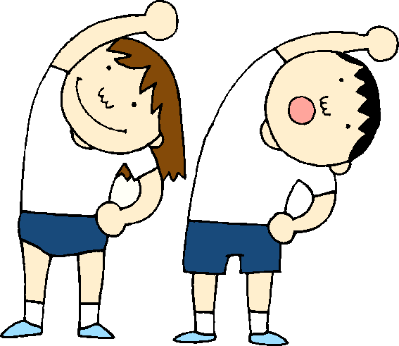
Timetable for Term 1

Monday | Tuesday | Wednesday | Thursday | Friday
Art with Mrs Matthews | Library  Class PE (weather permitting) | Assembly | Music with Mrs O’Gallagher  Activity Time | P.E with Mr Adey

This term, the children will be having their PE sessions outside as much as possible. Please ensure that the children have suitable clothing for this, including a pair of joggers/leggings and a hoodie or long sleeved top for cooler days. The children should also have both indoor and outdoor gymshoes/trainers. If girls come to school in tights please also include socks in their bags for PE sessions.

Dates for your diary!

Date | Event
Thurs 5th Oct, Tues 10th Oct, Wed 11th Oct | Parent Interviews
Friday 13th Oct | Last day of Term
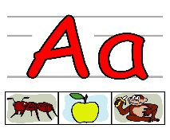

Literacy 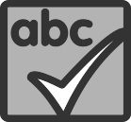

Phonics
Each week the children in P2 will be introduced to a new phonic sound. In P1 they will be introduced to two new sounds a week. This will be done through an active approach with a variety of activities to help the children practise. Some weeks will be used to consolidate their phonic knowledge.

Spelling
Each week the children will be given 4 spelling words in P2 and 3 spelling words in P1. The words are introduced to the children along with spelling strategies to help them to understand and retain the words. In class, we will practise the spelling words daily, through an active approach, and will discuss the strategies we have used to help us.

Writing
The P2 children will be developing their writing skills this term through a Personal Recount focus and also through some functional letter writing. We will continue to focus on using capital letters and full stops correctly and for those who are ready, on using a wider selection of joining words.
In P1 children will learn what a sentence is, learn to use finger spaces to separate words, later they will learn the importance of the capital and full stop.

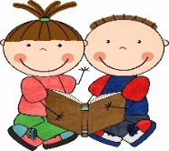
Reading
The P2 children will receive 2 reading books home each week. This term we will be concentrating on strategies for decoding unknown words. P1 will also receive 2 reading books a week. Some of these books will not have words and we are looking to develop the children’s ability to sequence and make sense of the story and to develop vocabulary. Later when they have books with words we will help them to learn to look at the picture and the sounds to help read.

Numeracy and Mathematics

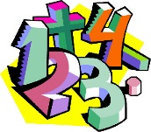
This term we will focussing on number knowledge. P2 will be learning about counting in sequences and using numbers to describe the order of items. We will be learning more about Place Value – looking at the value of digits within a number. We will also continue to develop our mental agility through using ‘counting on’ and ‘counting back’ to add and subtract numbers. P1 will be looking for numbers in the environment and finding out about different ways they can be used. They will be counting, recogniding numbers and number patterns, ordering and writing numbers.

We will also be exploring different aspects of Measure – recording and comparing different measurements using non-standard units.
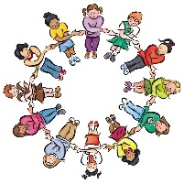

Health & Wellbeing and Other Curricular Areas

Health and Well Being
We will focus on settling into school and for P1 learning the routines. As a class this term we will be developing our understanding of rights and responsibilities within the school setting. Thinking of Elrick’s Vision, Values and Aims, we are working co-operatively together to create a class charter which will be our guide to help us to achieve a happy and calm learning environment in our class.

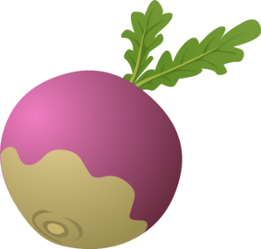
Contexts for Learning
Our first topic this term will be a literacy focus, based around Traditional Tales. We will be exploring different features of the book and will use the story to support and compliment our learning in Literacy, Expressive Arts and Health and Wellbeing and Numeracy.

Science
In Science this term we will be investigating aspects of Electricity.

Ideas to Help at Home

- Encourage your child to look for sounds and spelling words in the environment
- Read together for enjoyment and encourage your child to talk about the different features of the book eg. author, illustrator, blurb.
- Look out for different numbers in the environment and discuss the value of different digits.
- Measure and compare the height/weight and length of items around your home using non-standard units eg. hands, feet, crayons.
- Ask your child to discuss rules and how they keep us safe and help us to get along together
- Practise writing letters/spelling words in a variety of ways using different media

If there is anything that you wish to discuss further then please do not hesitate to ask.

Thank you for your help and support.

Mrs Young

