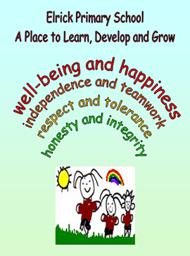
Primary 6LR Newsletter
Welcome to term 1!

Timetable

Monday | - Science
Tuesday | - Mindfulness  - Library
Wednesday | - Assembly  - French
Thursday | - P.E  - Homework due
Friday | - P.E.  - Homework uploaded to GLOW

Our class charter

As a class, we have decided upon these charter rules:
- To work together and support each other
- To not interrupt each other’s learning
- To respect each other
- To use the school property properly and respect it
- To have fun and smile while learning

Homework
Homework will be uploaded to GLOW on a Friday and should be handed in the following Thursday.

Reading

This term we will be using our class and group novels, to develop our reading skills, specifically our inference skills. Our current class novel is, ‘There’s a Boy in the Girls’ Classroom’, by Louis Sachar. The main novel themes are friendship, acceptance and bullying.

Every child should have an ERIC (Everybody Reading in Class) time book in class every day. This will be kept in their tray. If your child does not have a book to enjoy, they can borrow one from the class library.

Please remember to bring in library books in on a Tuesday.

Resources and Water Bottles
Every day in school you need: a pencil, water bottle, waterproof jacket and gym kit (your gym kit should include outdoor and indoor shoes). You can keep a water bottle in class and have access to it during the school day.

Numeracy and Mathematics
This term, we will be continuing to develop our understanding of place value, partitioning, rounding and using these as a strategy to solve various calculations. We will also be learning about improper and mixed number fractions. Additionally we will be applying our measurement knowledge to solve or investigate challenges.

Our daily CLIC sessions will improve our mental agility. This term we will focus on counting skills, reading and writing 6 digit numbers. Additionally we will develop our knowledge of adding, multiplying and dividing decimals.

Literacy

In writing, we will be focusing on up levelling our writing using a variety of more sophisticated vocabulary, interesting connectives and engaging sentence openers. As well as continuing to develop the use of punctuation in all of our written work. The genres we will focus on this term are; report, personal, imaginative, poetry and writing in a diary format.

We will continue to develop our spelling knowledge, consolidating our prior phoneme knowledge and using this to spell less-familiar and trickier words. This will allow us greater independence in our writing, and encourage us to use a wider vocabulary.

Health and Wellbeing and other Curricular Areas

Digital literacy continues to be a whole-school focus as we are incorporate the use of digital technology across the curriculum.

Mr Adey is developing our understanding of Elrick Primary School’s values and ethos. We are doing this while developing our growth mindset. Please ask us, ‘Who are you?’

We are working with Mrs Skinner, learning about sound and vibrations. She has lots of exciting practical experiments planned for this term.

We have been exploring health and wellbeing friendship and

How to help your child
- Talk to your child about their learning.
- Continue to encourage your child to talk about the learning pit and what strategies they are using to get out of it.
- Encourage your child to read for pleasure, discussing new and interesting vocabulary.
- Discuss our novel themes with us, and help us to explain what makes a good friend, and the acceptance of others.

