Primary 6 Newsletter

**Term 1**

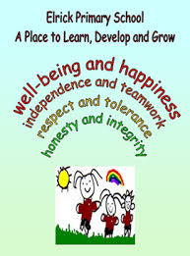

***The Elrick Rainbow***

**Timetable**

|  |  |
| --- | --- |
| Monday | * Art * P.E |
| Tuesday |  |
| Wednesday | * Assembly * French * Library |
| Thursday | * P.E * Homework due in |
| Friday | * Activity time * Homework uploaded to GLOW |

**Homework**

Homework will be uploaded to GLOW on a Friday and should be handed in the following Thursday.

**Reading**

Every child should have an ERIC (Everybody Reading in Class) time book in class every day. This will be kept in their tray. If your child does not have a book to enjoy, they can borrow one from the class library.

Please remember to bring in library books in on a Wednesday.

**Resources and Water Bottles**

Every day in school you need: a pencil, water bottle, waterproof jacket and gym kit (your gym kit should include outdoor and indoor shoes). You can keep a water bottle in class and have access to it during the school day.

**Numeracy and Mathematics**

This term, we will be continuing to develop our understanding of place value, partitioning, rounding, and learning new strategies to solve various calculations. We will also be learning about improper and mixed number fractions. Additionally, we will be applying our measurement knowledge to solve or investigate challenges.

Our daily CLIC sessions will improve our mental agility. This term we will focus on counting skills, reading and writing 6 digit numbers, and developing our knowledge of adding, multiplying and dividing decimals.

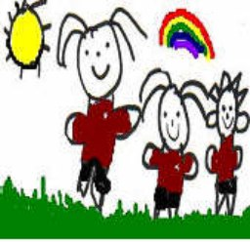

**How to help your child**

* Talk to your child about their learning.
* Continue to encourage your child to talk about the learning pit and what strategies they are using to get out of it.
* Encourage your child to read for pleasure, discussing new and interesting vocabulary.
* Discuss our novel themes with us, and help us to explain what makes a good friend, and the acceptance of others.

**I look forward to the year ahead.**

**Mrs Birt**

**Literacy**

In writing, we will be focusing on up-levelling our writing using a variety of more sophisticated vocabulary and interesting connectives, as well as continuing to develop the use of punctuation in all of our written work. The genre we will focus upon this term is imaginative writing.

We will continue to develop our spelling knowledge, consolidating our prior phoneme knowledge and using this to spell less-familiar and trickier words. This will allow us greater independence in our writing, and encourage us to use a wider vocabulary.

**Health and Wellbeing and other Curricular Areas**

Our topic is currently the class novel which is being used as a platform to work across the curriculum, linking our learning to the novel’s themes. In the second half of this term, we will focus on Health and Wellbeing, linking with work Mr Adey is currently doing to develop our understanding of Elrick Primary School’s values and ethos, developing our growth mindset and affirmations. Please ask us, ‘Who are you?’