I
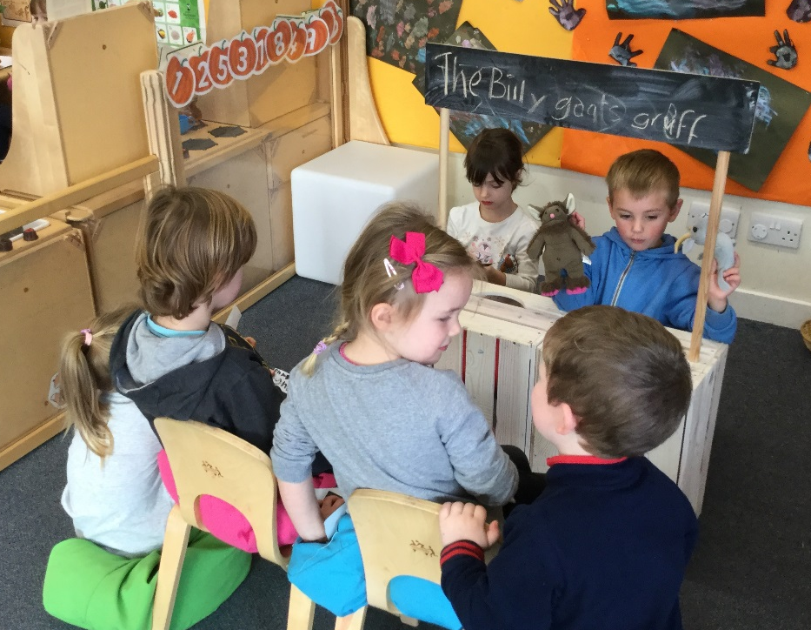 |  | Elrick Nursery  - Issue Date
A Place to learn, develop and grow |  | Newsletter 2 – December 2017

Term 2 is now in full swing and hopefully you have had a change to meet our new staff:

Miss Rose (Early Years Lead Practitioner) Monday to Wednesday
Miss Crockford (Early Years Lead Practitioner) Thursday, Friday

Mrs Beltran (Early Years Practitioner) Monday to Friday, 10.30 am – 1.30pm.

Mrs Farquhar (Early Years Practitioner) Monday to Friday.

Mrs Bond Early Years Practitioner) Monday to Wednesday

Mrs Shimwell (Early Years Practitioner) Wednesday to Friday.

Keyworker Groups
The keyworker groups this session are as follows:

LEOPARDS
Miss Rose/Miss Crockford/Mrs Beltran

ELEPHANTS
Mrs Bond
Mrs Shimwell

GIRAFFES
Mrs Farquhar

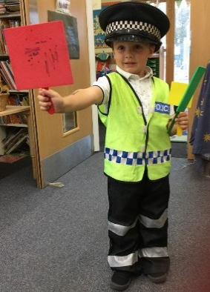
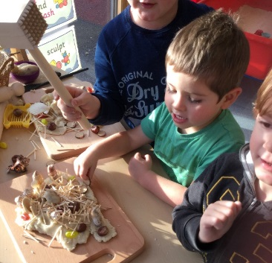

Our Learning
We are looking at enhancing our learning environment and this term we have been focusing on developing our play dough area. By removing the wellies from the back door we have been able to move the playdough from the kitchen into its own area which is easily accessed by the children throughout the session. We have introduced more natural resources such as wooden chopping boards, rolling pins, baking trays and some loose parts* for them to expand their creativity. The children asked for cook books and cupcake holders which we have added. The children are thoroughly enjoying learning in this area. If you would like to help us develop the area further, we would be grateful for donations of children’s cookbooks and any old kitchen utensils.
*loose parts (https://www.inspiringscotland.org.uk/wp-content/uploads/2017/03/Loose-Parts-Play-web.pdf)

Reporting Progress Opportunities
We hope you were able to take advantage of our stay and play sessions to share with your child their learning. As always we thank you for your support and all your valuable comments. Some of the feedback was asking for more regular stay and play sessions which we can confirm we will hold every term.
By the end of this term your child will have been our focus child for a week and you should have had a meeting to discuss their progress and next steps. We will be starting round 2 in the New Year.
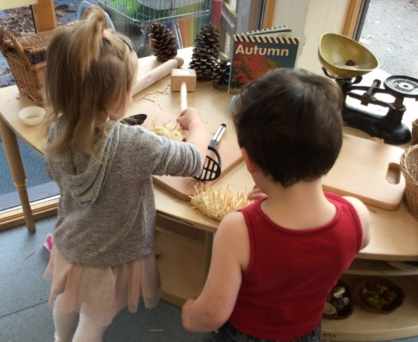

Christmas Events
This year we will be hosting a shared extravaganza with our Primary 6 classes on Tuesday 19th December called Carols and Cakes. The P6 children will be issuing you with invites and further details shortly but the times for your diaries are:
Blue 10.45 am – 11.45 am
Green 2.10 pm - 3.10pm
Friday, 15th December – Wear your Christmas/Favourite Jumper day

On Wednesday 20 December we will be taking the children to BA stores to see Santa, visit the Christmas room and take a tractor ride. This will all happen within the children’s normal session but we will need your help on the bus and during the stay at BA Stores. If you can help please let a member of the nursery team know. Unfortunately, we cannot accommodate siblings. The cost for the trip is £5 per child which we would appreciate if you could put this in a sealed envelope with your child’s name and class and give it to a member of the nursery team. Thank you.
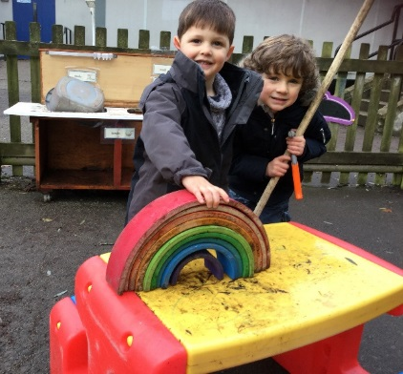

Outdoor Play
We appreciate your support and understating this term when we returned the nursery wellies for you to store. As you can see we have managed to create a more inviting space for your child to learn by removing the wellies from our back door. It is also optimising learning time during the day with one less shoe change. May we remind you to send your child in appropriate footwear and clothing to nursery as we will be outside daily, in all weathers.
Snack
Snack envelopes have been sent home for term 2 and money should be returned in the envelope provided. Please put in the correct cash or a cheque made payable to Elrick Primary. Thank You

Parent Zone
We want you to be part of our Nursery community and will be asking for you to accompany our children on trips to explore our wider community. If you are able to help please let a member of our team know.

We welcome your comments which you can leave on our Community Board or please feel free to chat to a member of our team at the start and the end or end of a session.

Many thanks
The Nursery Team

